**Practical 1:**

**Aim: LINUX COMMANDS: EXPLORING THE RASPBIAN**

**LINUX COMMANDS**

Here are some fundamental and common Linux commands with example usage:

**FILESYSTEM commands:**

* LS : The ls command lists the content of the current directory (or one that is specified). It can be used with the -l flag to display additional information (permissions, owner, group, size, date and timestamp of last edit) about each file and directory in a list format. The -a flag allows you to view files beginning with . (i.e. dotfiles).

* CD : Using cd changes the current directory to the one specified. You can use relative (i.e. cd directoryA) or absolute (i.e. cd /home/pi/directoryA) paths.

* PWD : The pwd command displays the name of the present working directory: on a Raspberry Pi, entering pwd will output something like /home/pi.

* MKDIR : You can use mkdir to create a new directory, e.g. mkdir newDir would create the directory newDir in the present working directory.

* RMDIR : To remove empty directories, use rmdir. So, for example, rmdir oldDir will remove the directory oldDir only if it is empty.

* RM : The command rmremoves the specified file (or recursively from a directory when used with -r). Be careful with this command: files deleted in this way are mostly gone for good!

* CP : Using cp makes a copy of a file and places it at the specified location (this is similar to copying and pasting). For example, cp ~/fileA /home/otherUser/would copy the file fileA from your home directory to that of the user otherUser (assuming you have permission to copy it there). This command can either take FILE FILE (cp fileA fileB), FILE DIR(cp fileA /directoryB/) or -r DIR DIR (which recursively copies the contents of directories) as arguments.

* MV : The mv command moves a file and places it at the specified location (so where cp performs a 'copy-paste', mv performs a 'cut-paste'). The usage is similar to cp. So mv ~/fileA /home/otherUser/ would move the file fileA from your home directory to that of the user otherUser. This command can either take FILE FILE (mv fileA fileB), FILE DIR (mv fileA /directoryB/) or DIR DIR (mv /directoryB /directoryC) as arguments. This command is also useful as a method to rename files and directories after they've been created.

* TOUCH : The command touch sets the last modified time-stamp of the specified file(s) or creates it if it does not already exist.

* CAT : You can use cat to list the contents of file(s), e.g. cat thisFile will display the contents of thisFile. Can be used to list the contents of multiple files, i.e. cat *.txt will list the contents of all .txt files in the current directory.

* HEAD : The head command displays the beginning of a file. Can be used with -n to specify the number of lines to show (by default ten), or with -c to specify the number of bytes.

* TAIL : The opposite of head, tail displays the end of a file. The starting point in the file can be specified either through -b for 512 byte blocks, -c

for bytes, or -n for number of lines.

* CHMOD : You would normally use chmod to change the permissions for a file. The chmodcommand can use symbols u (user that owns the file), g (the files group) , and o (other users) and the permissions r (read), w (write), and x (execute). Using chmod u+x *filename* will add execute permission for the owner of the file.

* CHOWN : The chown command changes the user and/or group that owns a file. It normally needs to be run as root using sudo e.g. sudo chown pi:root *filename* will change the owner to pi and the group to root.

* SSH : ssh denotes the secure shell. Connect to another computer using an encrypted network connection. For more details see SSH (secure shell)

* SCP : The scp command copies a file from one computer to another using ssh. For more details see SCP (secure copy)

* SUDO : The sudo command enables you to run a command as a superuser, or another user. Use sudo -s for a superuser shell. For more details see Root user / sudo

* DD : The dd command copies a file converting the file as specified. It is often used to copy an entire disk to a single file or back again. So, for example, dd if=/dev/sdd of=backup.img will create a backup image from an SD card or USB disk drive at /dev/sdd. Make sure to use the correct drive when copying an image to the SD card as it can overwrite the entire disk.

* DF : Use df to display the disk space available and used on the mounted filesystems. Use df -h to see the output in a human-readable format using M for MBs rather than showing number of bytes.

* UNZIP : The unzip command extracts the files from a compressed zip file.
* TAR : Use tar to store or extract files from a tape archive file. It can also reduce the space required by compressing the file similar to a zip file. To create a compressed file, use tar -cvzf *filename.tar.gz* *directory/* To extract the contents of a file, use tar -xvzf *filename.tar.gz*

* ssinput for another command. The pipe symbol is a vertical line |. For example, to only show the first ten entries of the ls command it can be piped through the head command ls | head

* TREE : Use the tree command to show a directory and all subdirectories and files indented as a tree structure. & Run a command in the background with &, freeing up the shell for future commands.

* WGET : Download a file from the web directly to the computer with wget. So wget

https://www.raspberrypi.org/documentation/linux/usage/commands.mdwi ll download this file to your computer as commands.md

* CURL :Use curl to download or upload a file to/from a server. By default, it will output the file contents of the file to the screen.

* MAN : Show the manual page for a file with man. To find out more, run man man to view the manual page of the man command.

**SEARCH COMMANDS**

* GREP : Use grep to search inside files for certain search patterns. For example, grep "search" *.txt will look in all the files in the current directory ending with .txt for the string search. The find command searches a directory and subdirectories for files matching certain patterns.

* WHEREIS : Use whereis to find the location of a command. It looks through standard program locations until it finds the requested command.

**NETWORKING COMMANDS:**

* PING : The ping utility is usually used to check if communication can be made with another host. It can be used with default settings by just specifying a hostname (e.g. ping raspberrypi.org) or an IP address (e.g. ping 8.8.8.8). It can specify the number of packets to send with the -c flag.

* NMAP : nmap is a network exploration and scanning tool. It can return port and OS information about a host or a range of hosts. Running just nmap will display the options available as well as example usage.

* HOSTNAME : The hostname command displays the current hostname of the system. A privileged (super) user can set the hostname to a new one by supplying it as an argument (e.g. hostname new-host).

* IFCONFIG : Use ifconfig to display the network configuration details for the interfaces on the current system when run without any arguments (i.e. ifconfig). By supplying the command with the name of an interface (e.g. eth0 or lo) you can then alter the configuration.

**Practical 2:**

**Aim : To Perform Bash Commands**

1. Create a bash file with following structure

f1/f2/t1

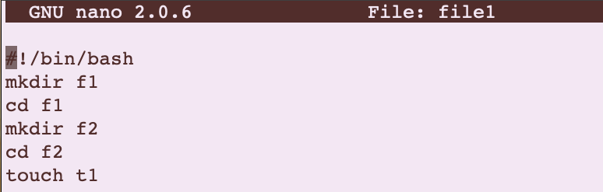

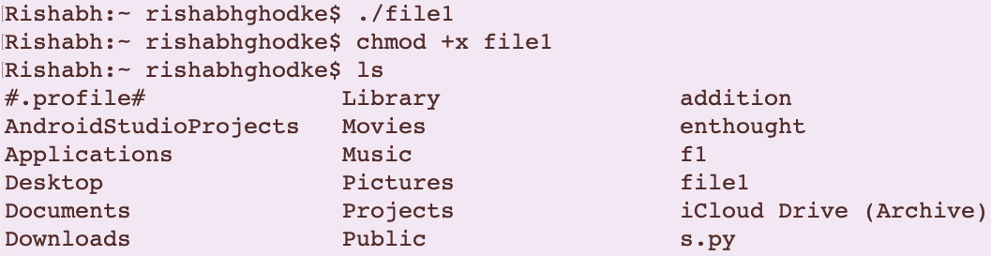

2.Create a bash file with following

a. man pwd

b. man touch

c. man cp

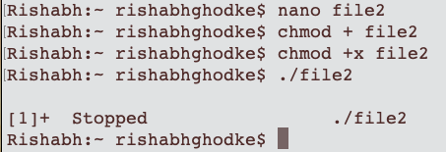

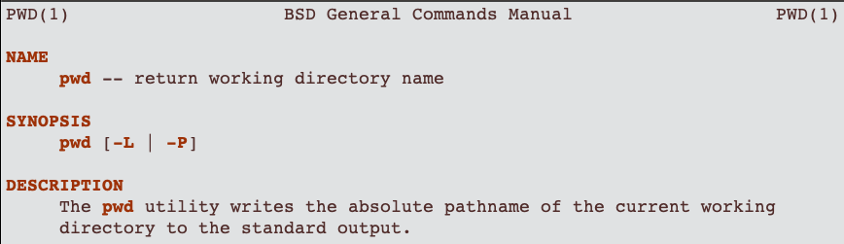

3.Create a bash file to perform Arithmetic Operations

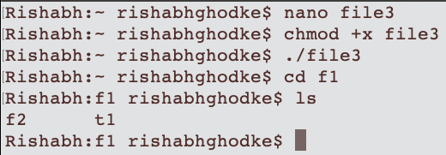

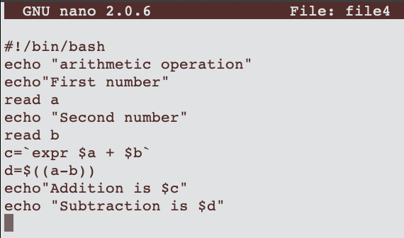

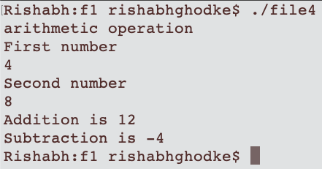

4.Create a bash file to check weather numbers are same

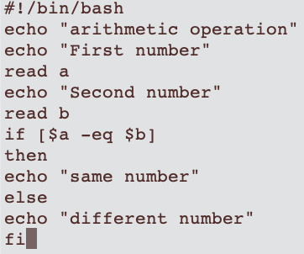

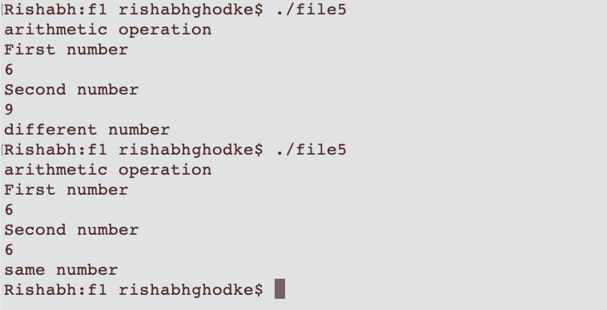

5.Create a bash file to perform Multiplication

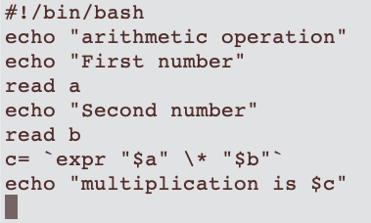

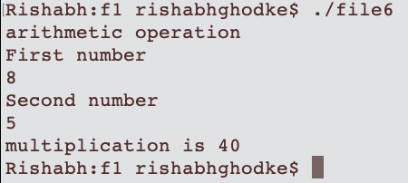

6.Create a bash file to perform switch case operation

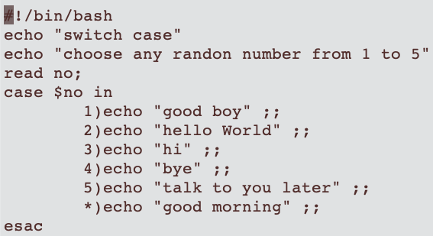

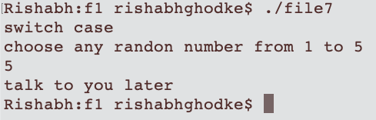

2.Create Bash File to create Touch file m1,m2,m3,m4

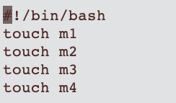

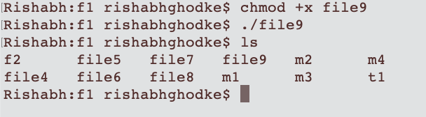

3.Create Bash File to create cat file m1,m2,m3,m4

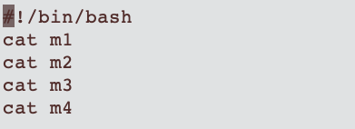

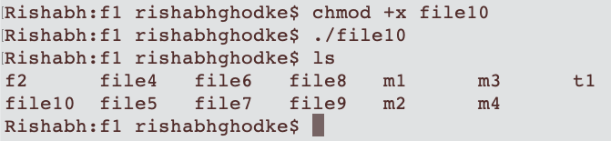

**Practical 3:**

Aim : Learn to ssh into a raspberry pi using putty from a different computer on the network.

Steps for transferring file from windows to raspberry:

Step 1: Find out the IP address of raspberry - ifconfig

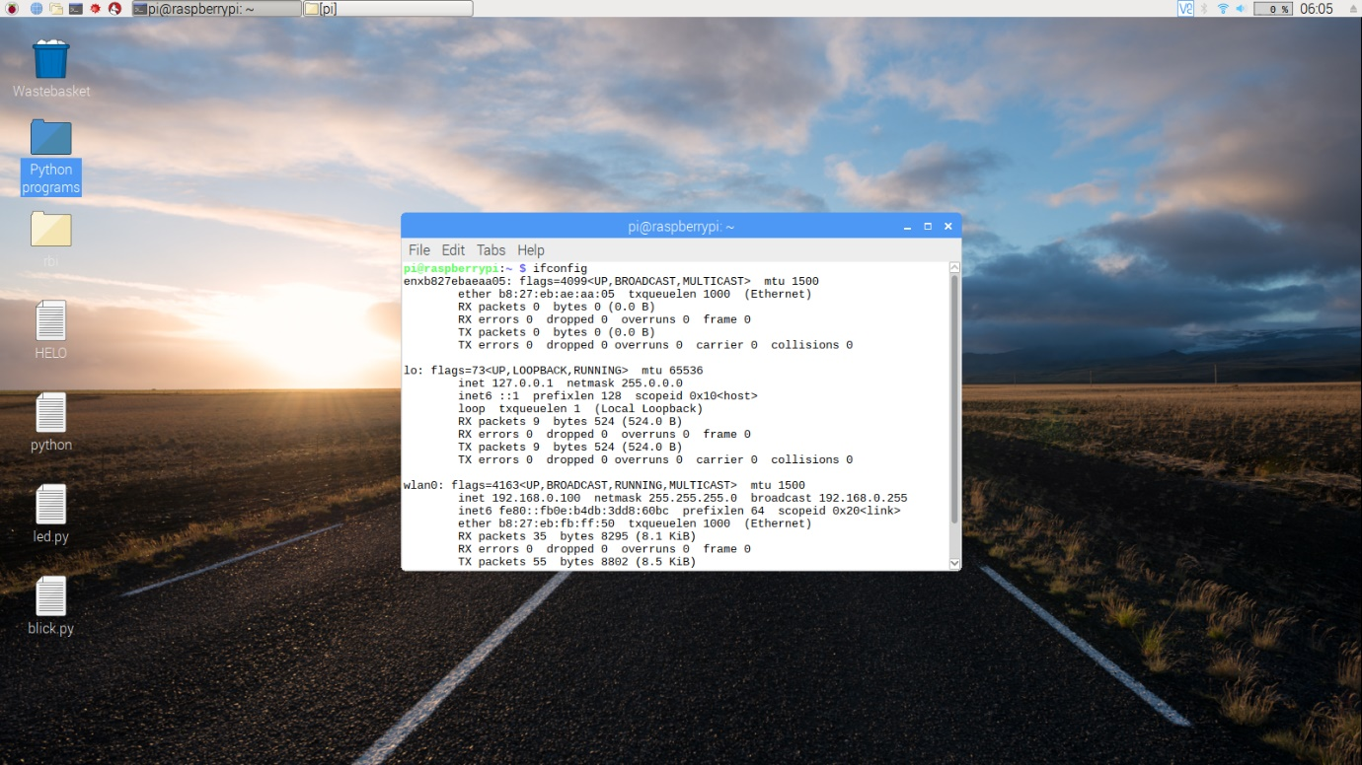

Step 2: Make the setting of SSH connection in raspberry

Type – sudo raspi -config

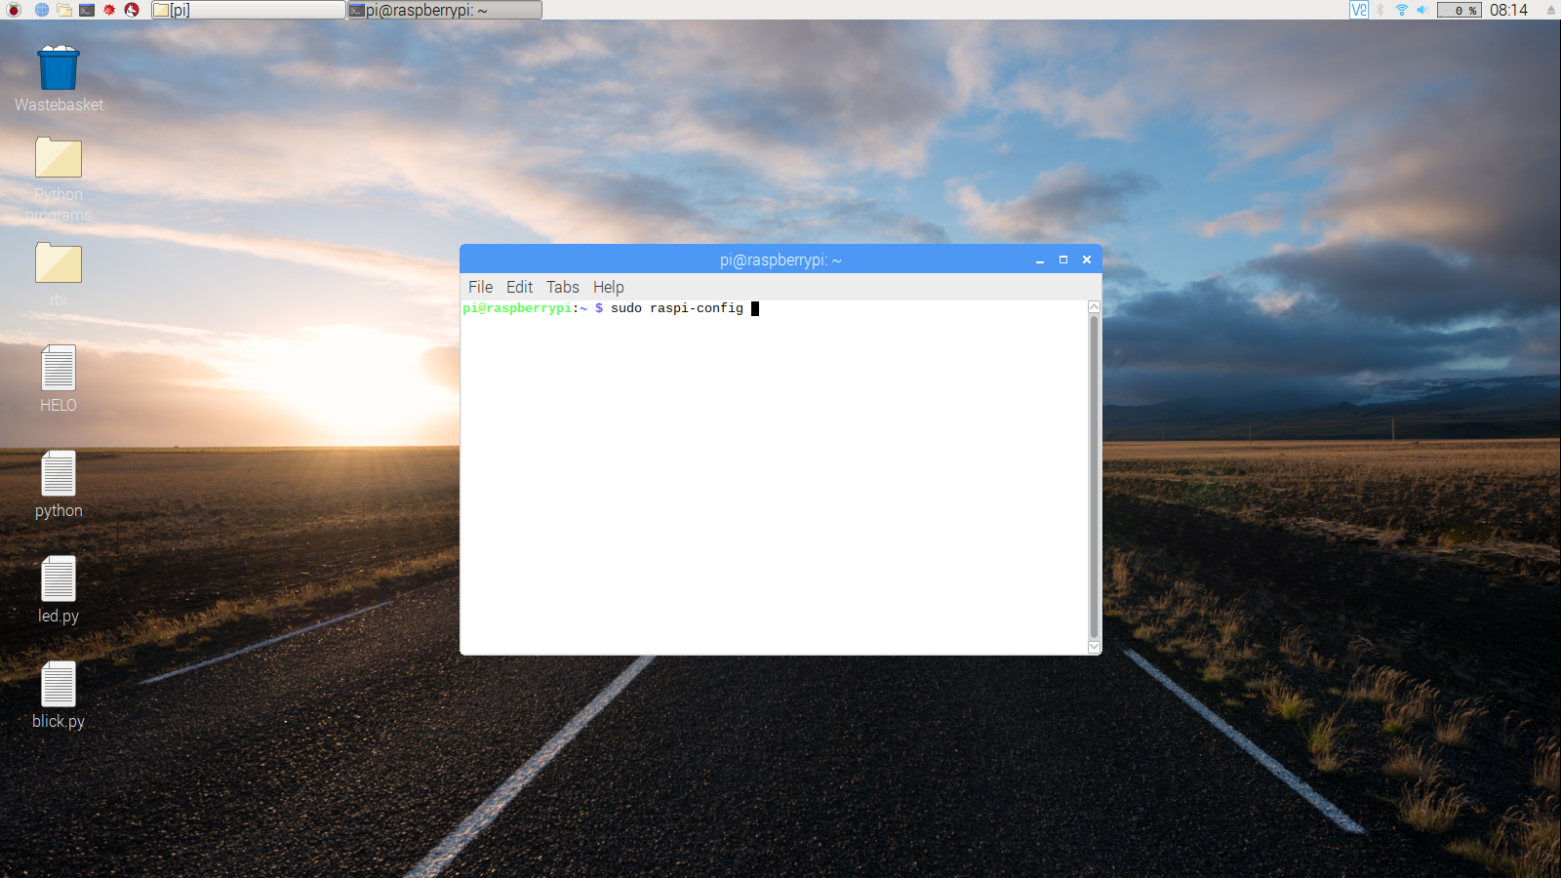

Select Interfacing Options

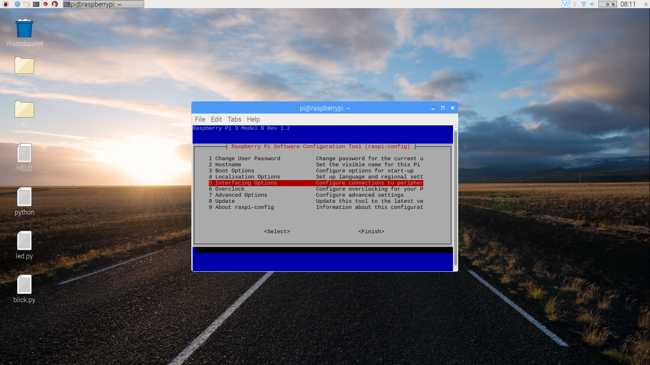

Select SSH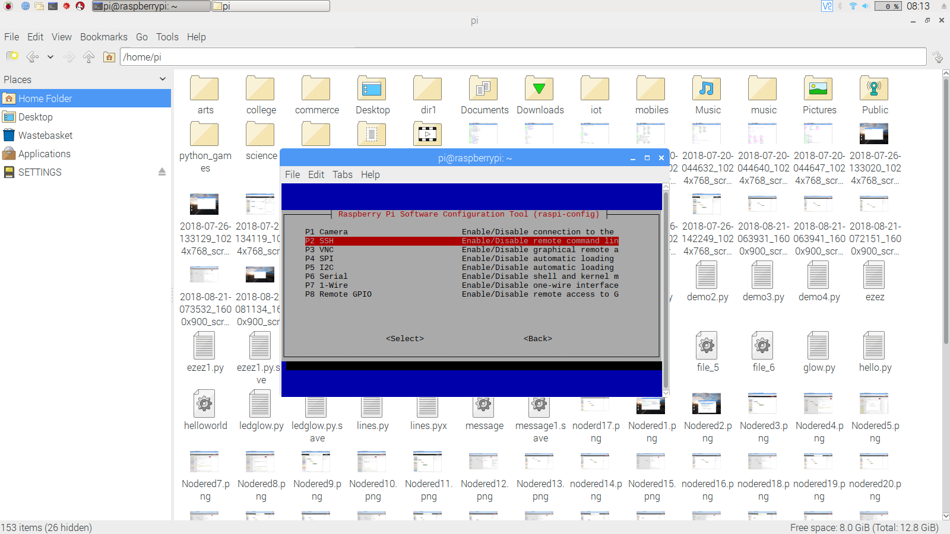

Enable SSH

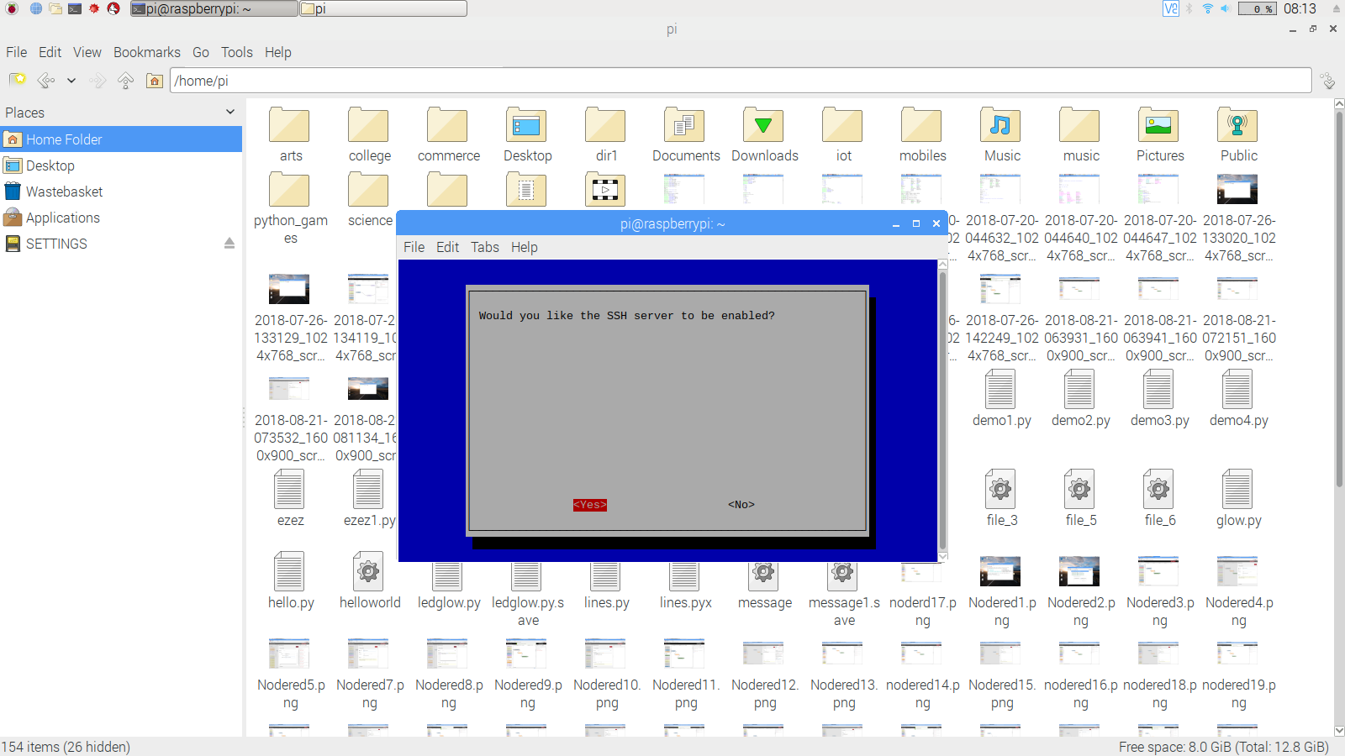

Then Click on OK

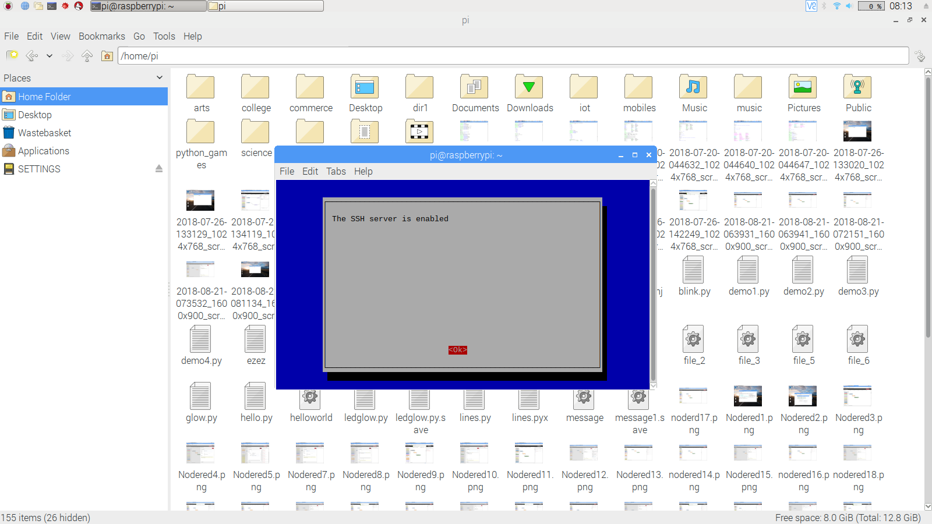

Step 3: Download putty server on your desktop

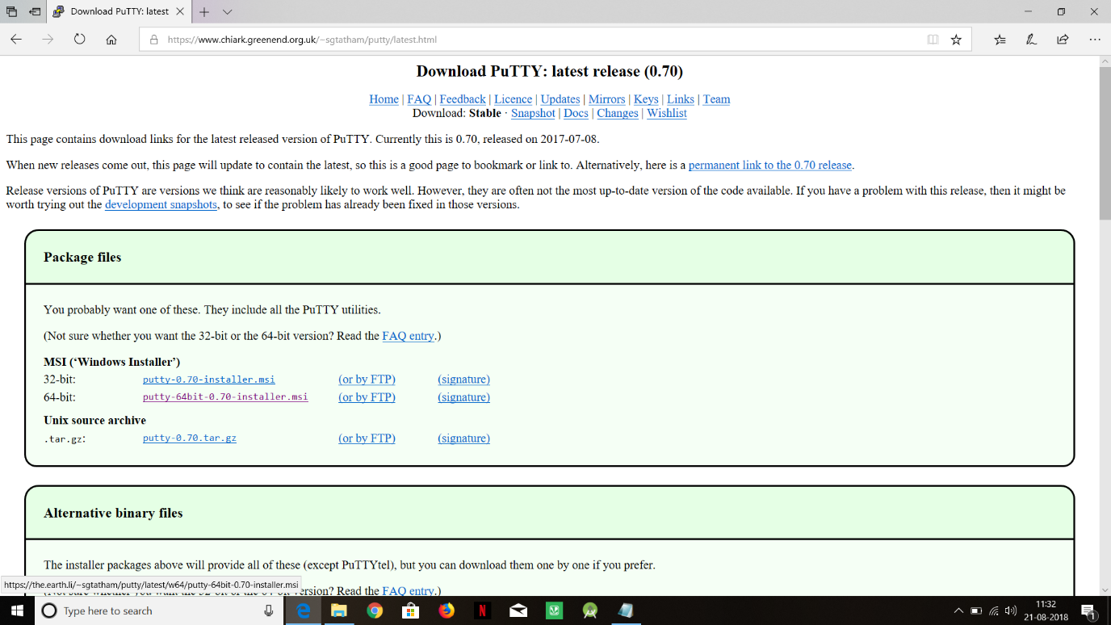

Step 4: Install putty server

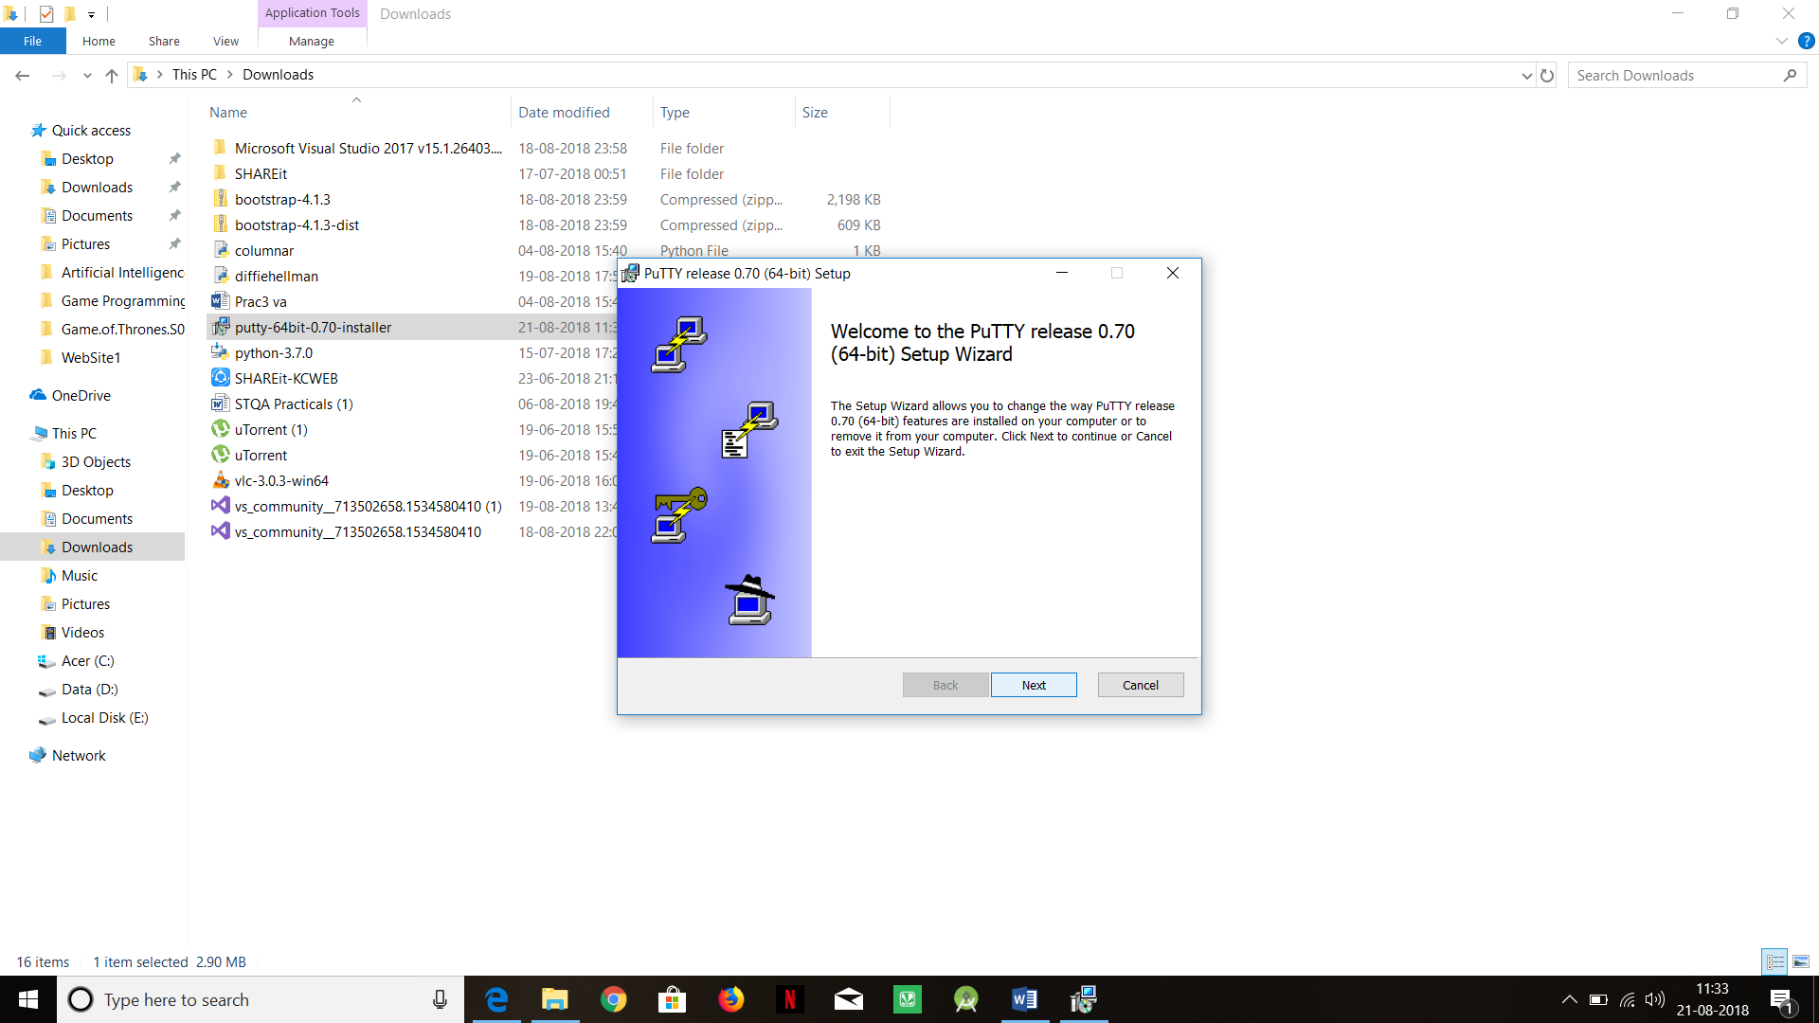

Step 5: Open putty server, then write the Hostname or IP address of raspberry

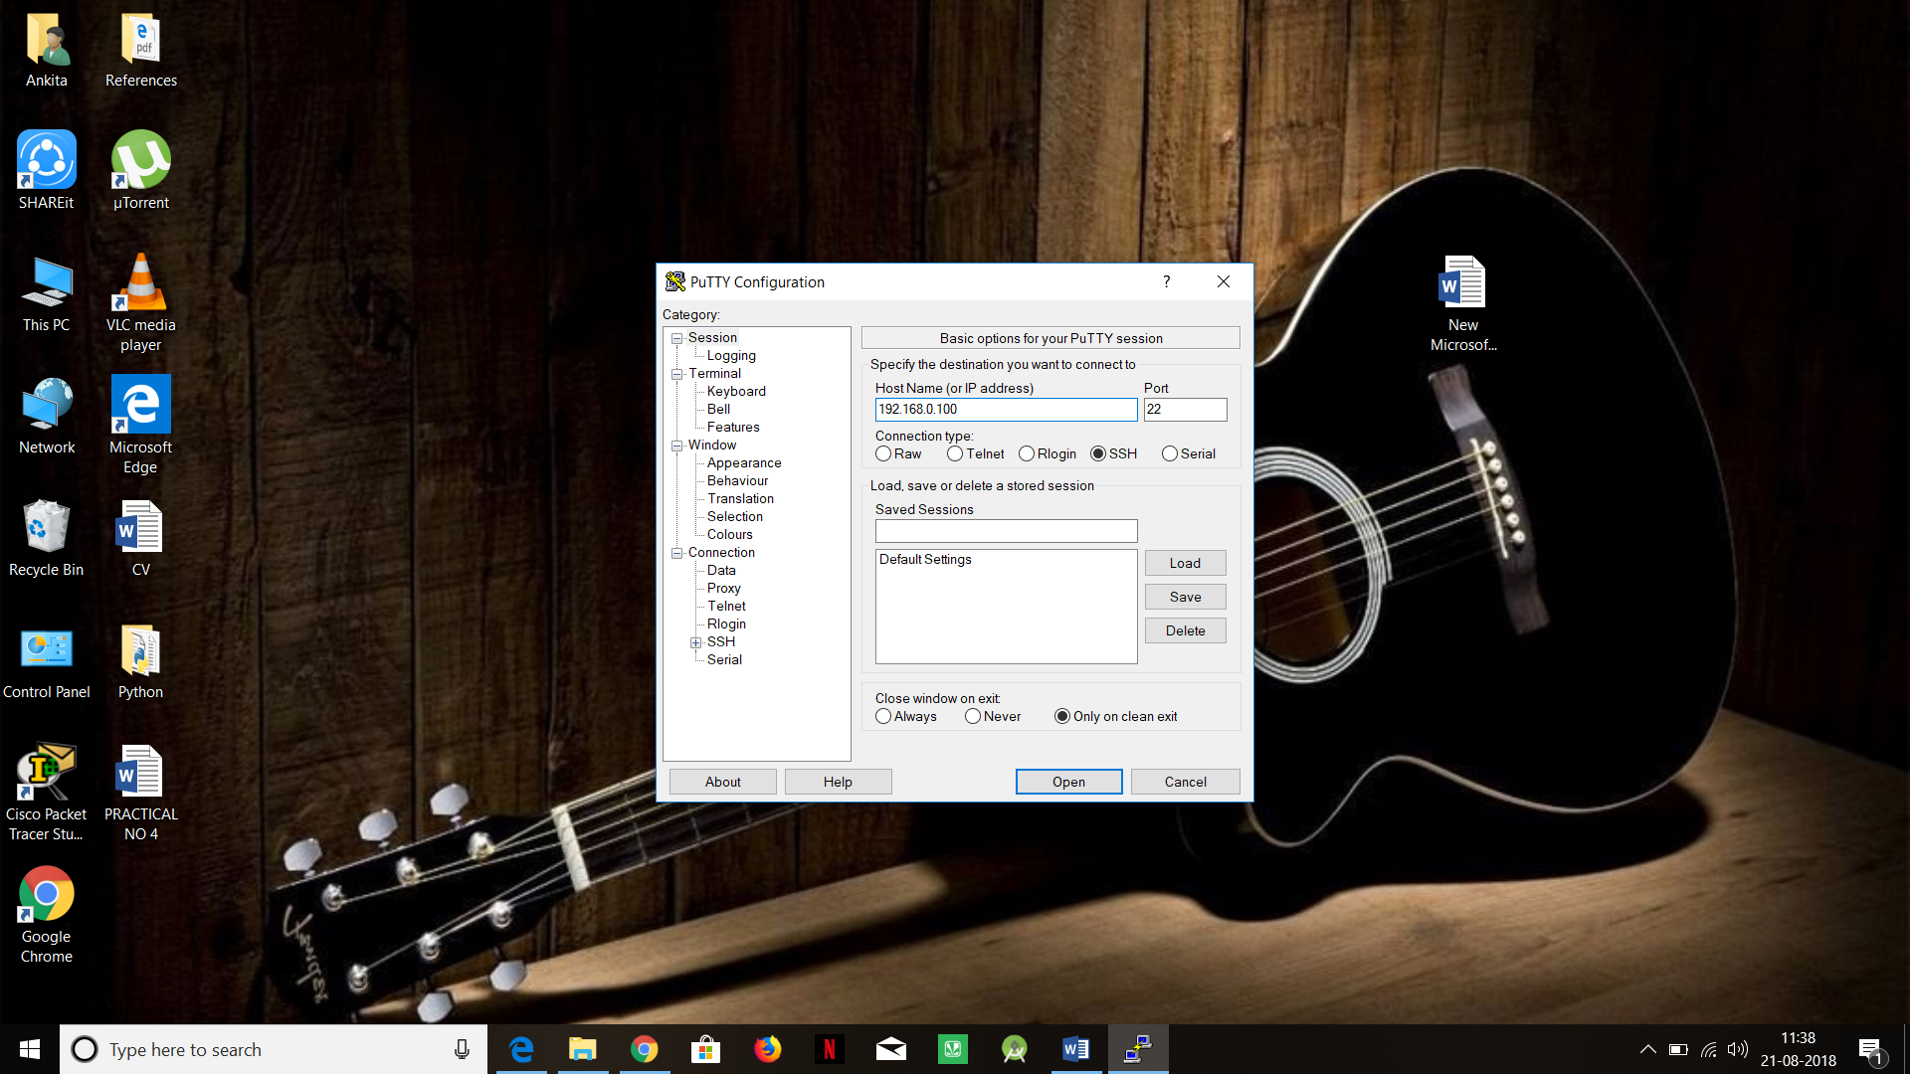

Step 6: Once it is connected it will ask for login & password of raspberry which is “pi” & “raspberry” respectively

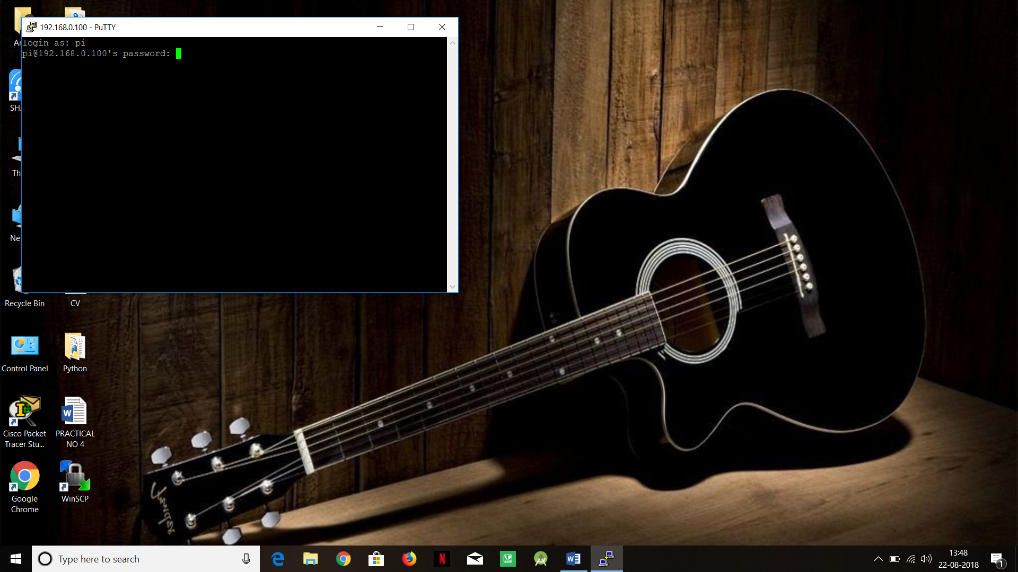

Step 7: Download WinSCP to transfer the file from your desktop to raspberry & vice versa

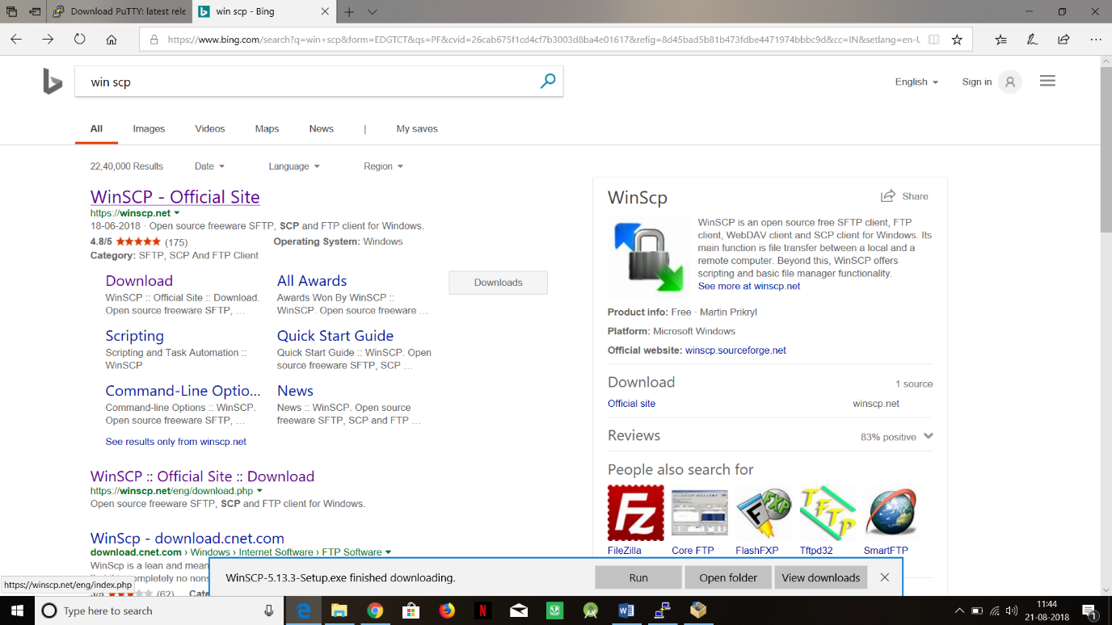



Step 8: Install WinSCP

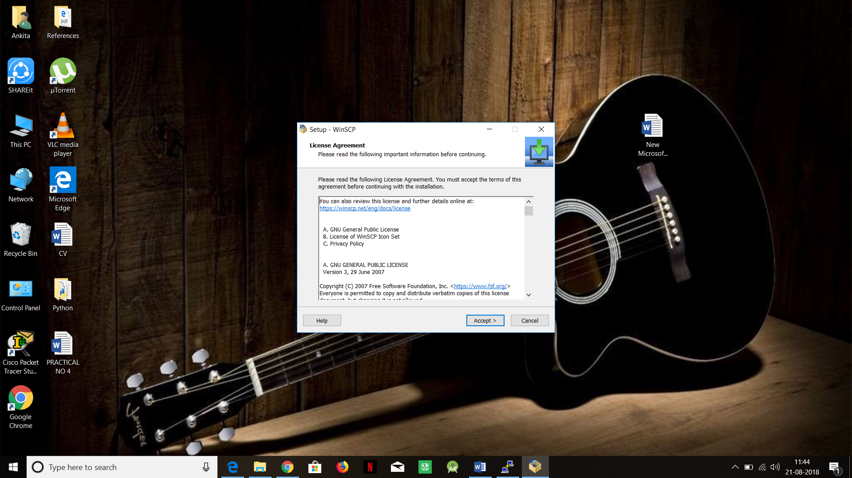

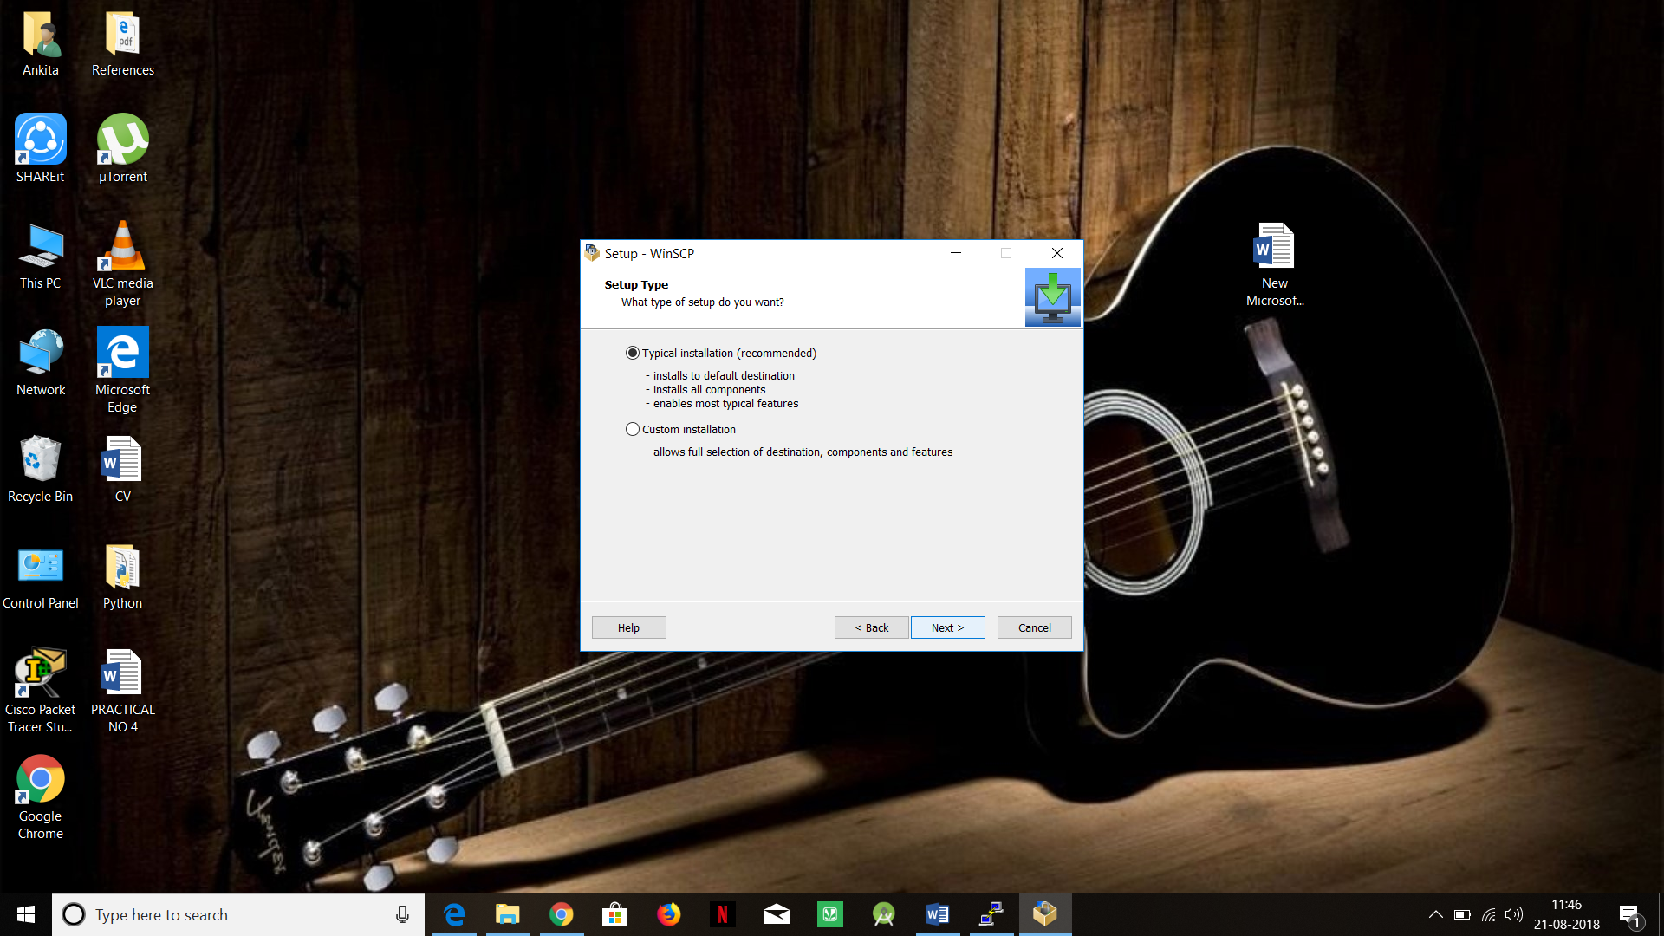

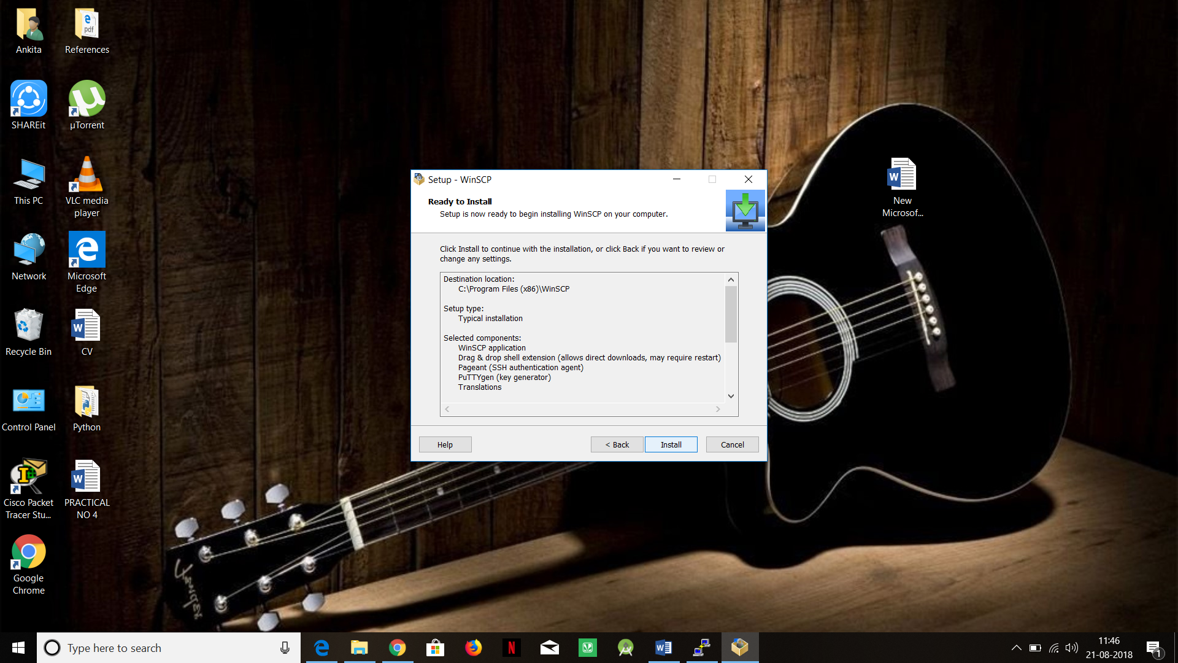

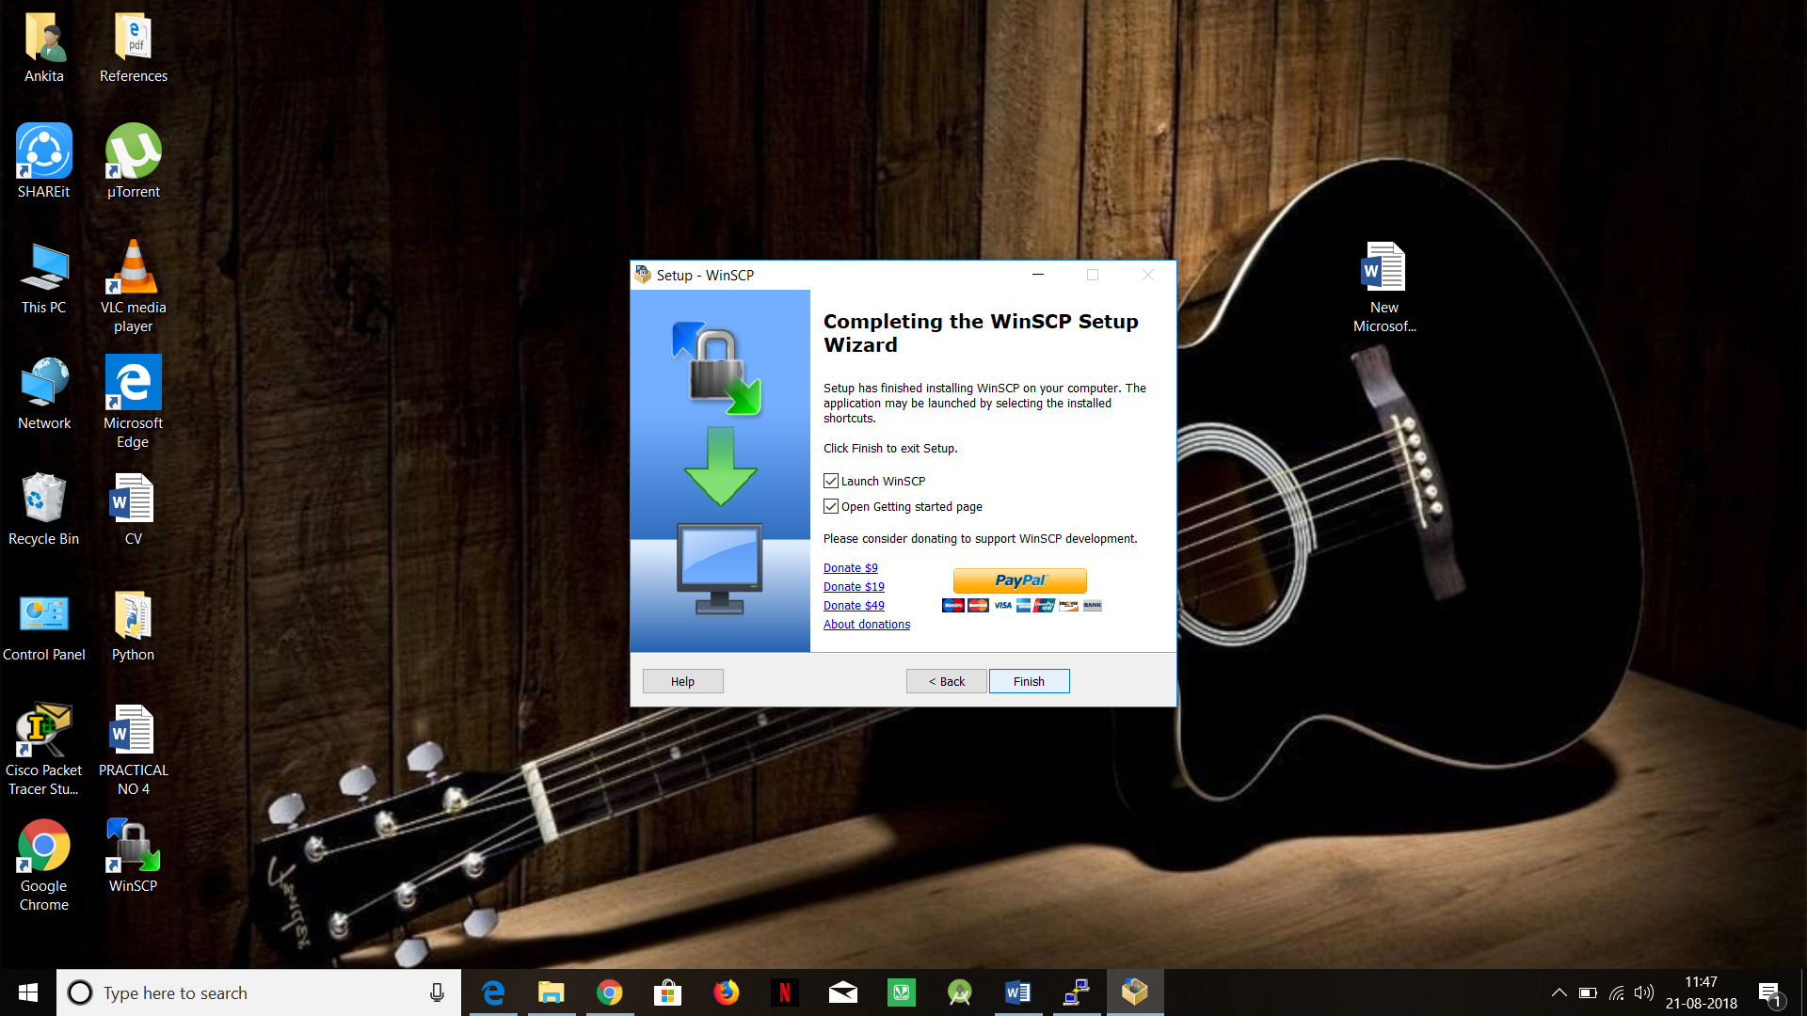

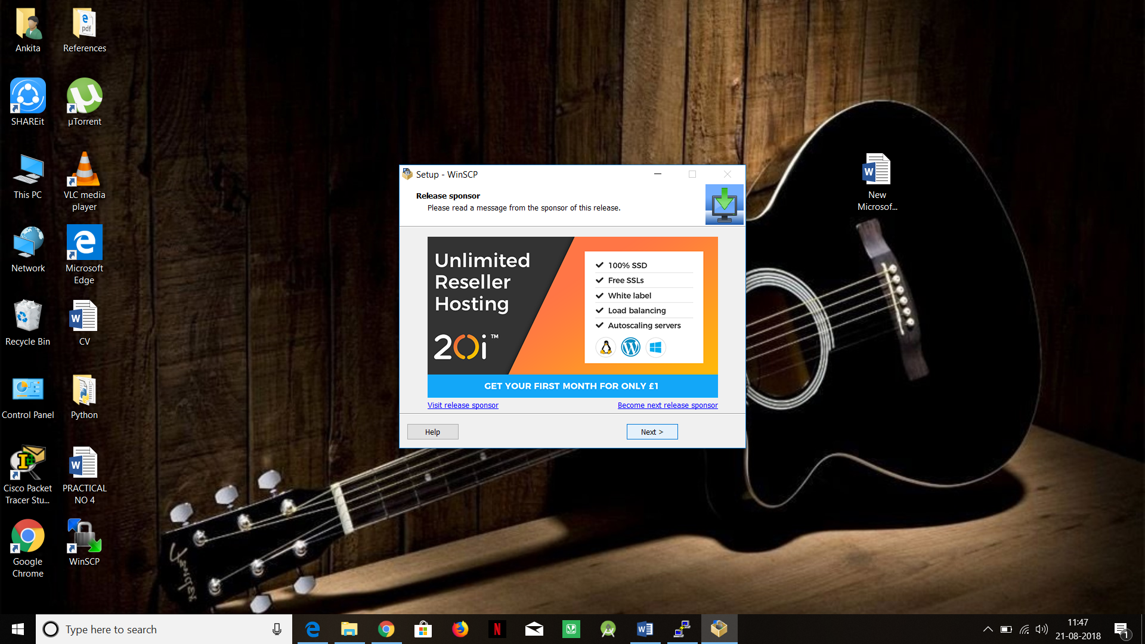

Step 9: Open WinSCP then enter the IP address, username & password

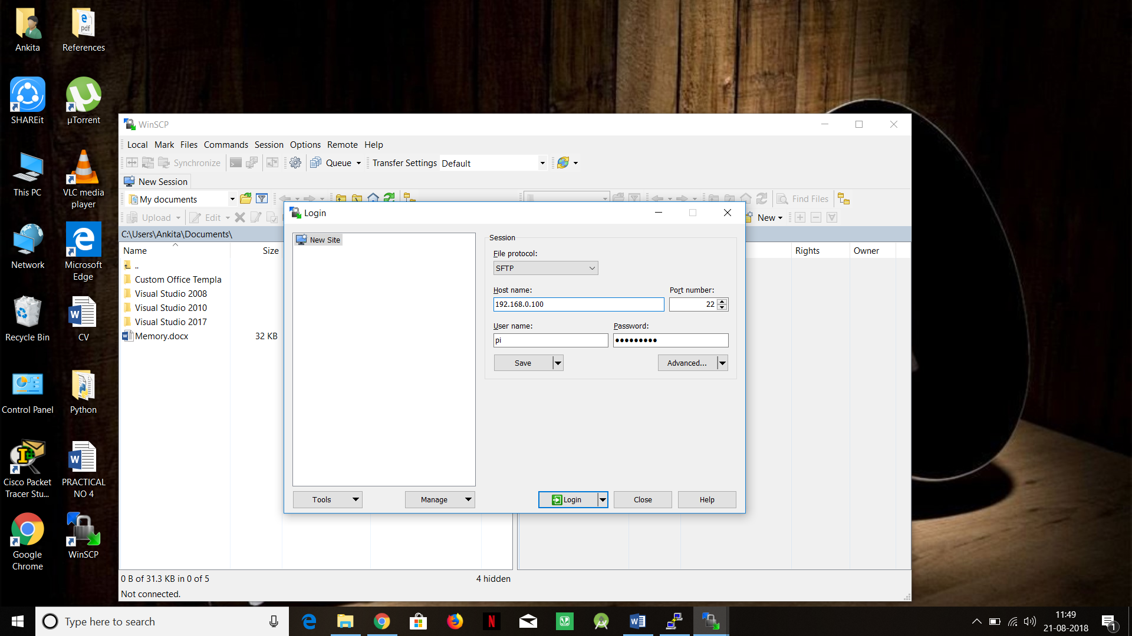

Step 10: You can view two screens on desktop first is of desktop & other is of raspberry

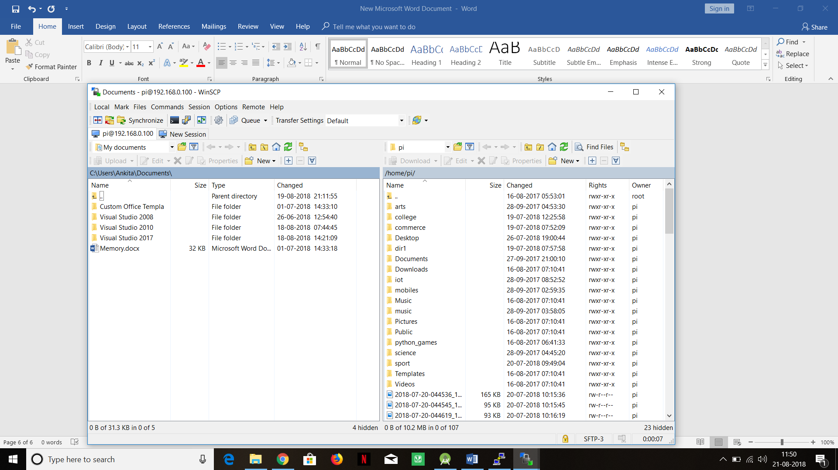

Step 11: Now you can easily transfer the files from one end to another end

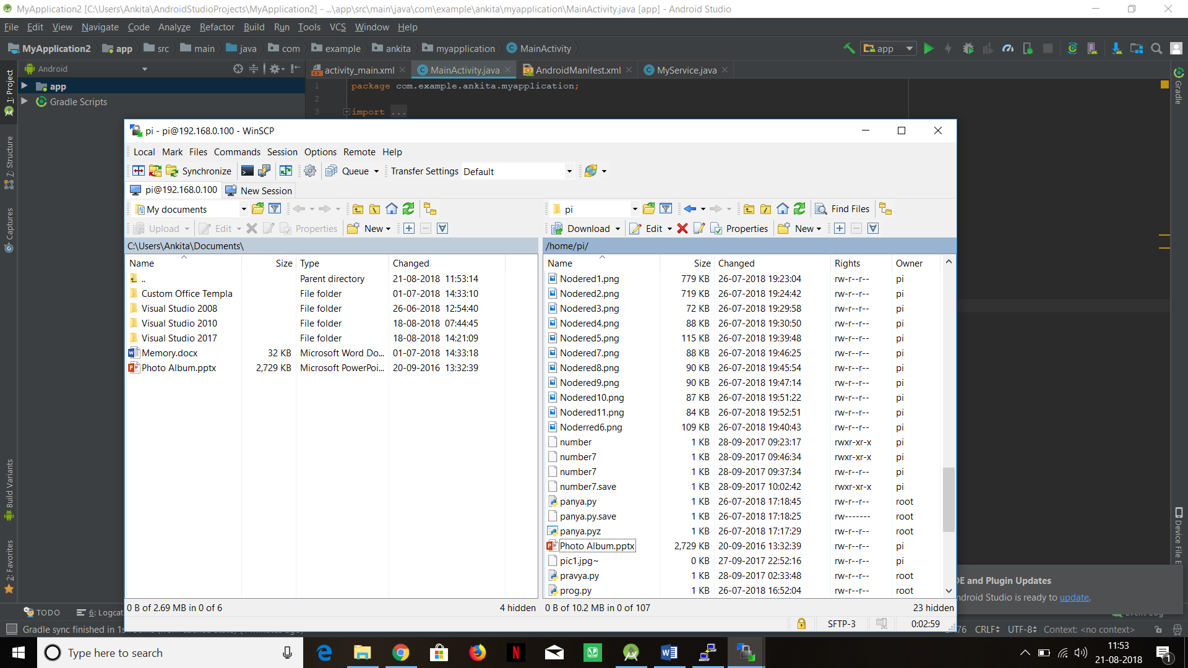

**Practical 4:**

**AIM:GPIO : Light The LED With Python on Breadboard.**

**The Breadboard**

The breadboard is a way of connecting electronic components to each other without having to solder them together. The holes on the breadboard are connected in a pattern.

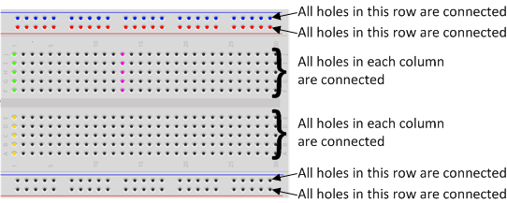

With the breadboard in the CamJamEduKit, the top row of holes are all connected together – marked with red dots. And so are the second rows of holes – marked with blue dots. The same goes for the two rows of holes at the bottom of the breadboard.

In the middle, the columns of wires are connected together with a break in the middle. So for.

**The LED**

LED stands for Light Emitting Diode, and glows when electricity is passed through it.

When you pick up the LED, you will notice that one leg is longer than the other. The longer leg (known as the ‘anode’), is always connected to the positive supply of the circuit. The shorter leg (known as the ‘cathode’) is connected to the negative side of the power supply, known as ‘ground’.

**The Resistor**

You must ALWAYS use resistors to connect LEDs up to the GPIO pins of the Raspberry Pi. The Raspberry Pi can only supply a small current (about 60mA). The LEDs will want to draw more, and if allowed to they will burn out the Raspberry Pi. Therefore putting the resistors in the circuit will ensure that only this small current will flow and the Pi will not be damaged.

**Jumper Wires**

Jumper wires are used on breadboards to ‘jump’ from one connection to another. The ones you will be using in this circuit have different connectors on each end. The end with the ‘pin’ will go into the Breadboard. The end with the piece of plastic with a hole in it will go onto the Raspberry Pi’s GPIO pins.

**The Raspberry Pi's GPIO Pins**

**GPIO** stands for **General Purpose Input Output**. It is a way the Raspberry Pi can control and monitor the outside world by being connected to electronic circuits.

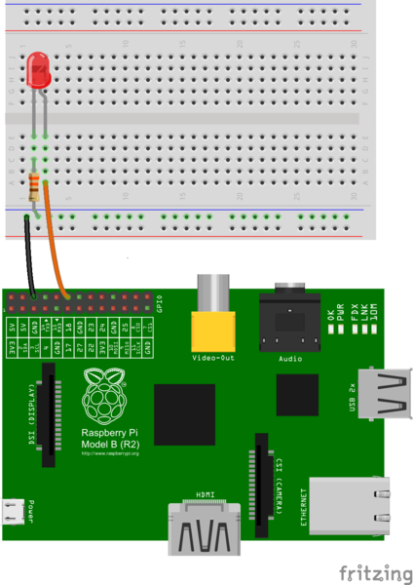

You should turn your Pi off for the next bit, just in case you accidentally short something out.

* Use one of the jumper wires to connect a ground pin to the rail, marked with blue, on the breadboard. The female end goes on the Pi's pin, and the male end goes into a hole on the breadboard.
* Then connect the resistor from the same row on the breadboard to a column on the breadboard, as shown above.
* Next, push the LEDs legs into the breadboard, with the long leg (with the kink) on the right.

**Write a Python Code to glow an LED on (Using BOARD mode) :->**

**Step 1 : Source Code**

*Nano LED.py*

import time

import RPi.GPIO as GPIO

GPIO.setmode(GPIO.BOARD)

GPIO.setup(8, GPIO.OUT)

GPIO.output(8,False)

while True:

GPIO.output(8,False)

Once you have typed all the code and checked it, save and exit the text editor with “Ctrl + x” then “y” then “enter”.

**Step 2 : Running the Code**

To run this code type:

*sudo python LED.py*

You will see the LED turn on for a second and then turn off.

Explanation

|  |  |
| --- | --- |
| import RPi.GPIO as GPIO | The first line tells the Python interpreter (the thing that runs the Python code) that it will be using a ‘library’ that will tell it how to work with the Raspberry Pi’s GPIO pins.  A ‘library’ gives a programming language extra commands that can be used to do something different that it previously did not know how to do.  This is like adding a new channel to your TV so you can watch something different. |
| import time | Imports the Time library so that we can pause the script later on. |
| GPIO.setmode(GPIO.BOARD) | Each pin on the Pi has several different names, so you need to tell the program which naming convention is to be used. |
| GPIO.setwarnings(False) | This tells Python not to print GPIO warning messages to the screen. |
| GPIO.setup(8, GPIO.OUT) | This line tells the Python interpreter that pin 18 is going to be used for outputting information, which means you are going to be able to turn the pin ‘on’ and ‘off’. |
| GPIO.output(8,True) | This turns the GPIO pin ‘on’. What this actually means is that the pin is made to provide power of 3.3volts.  This is enough to turn the LED in our circuit on. |
| time.sleep(1) | Pauses the Python program for 1 second |
| GPIO.output(8,False) | This turns the GPIO pin ‘off’, meaning that the pin is no longer supplying any power. |
|  |  |

The output look like below image :

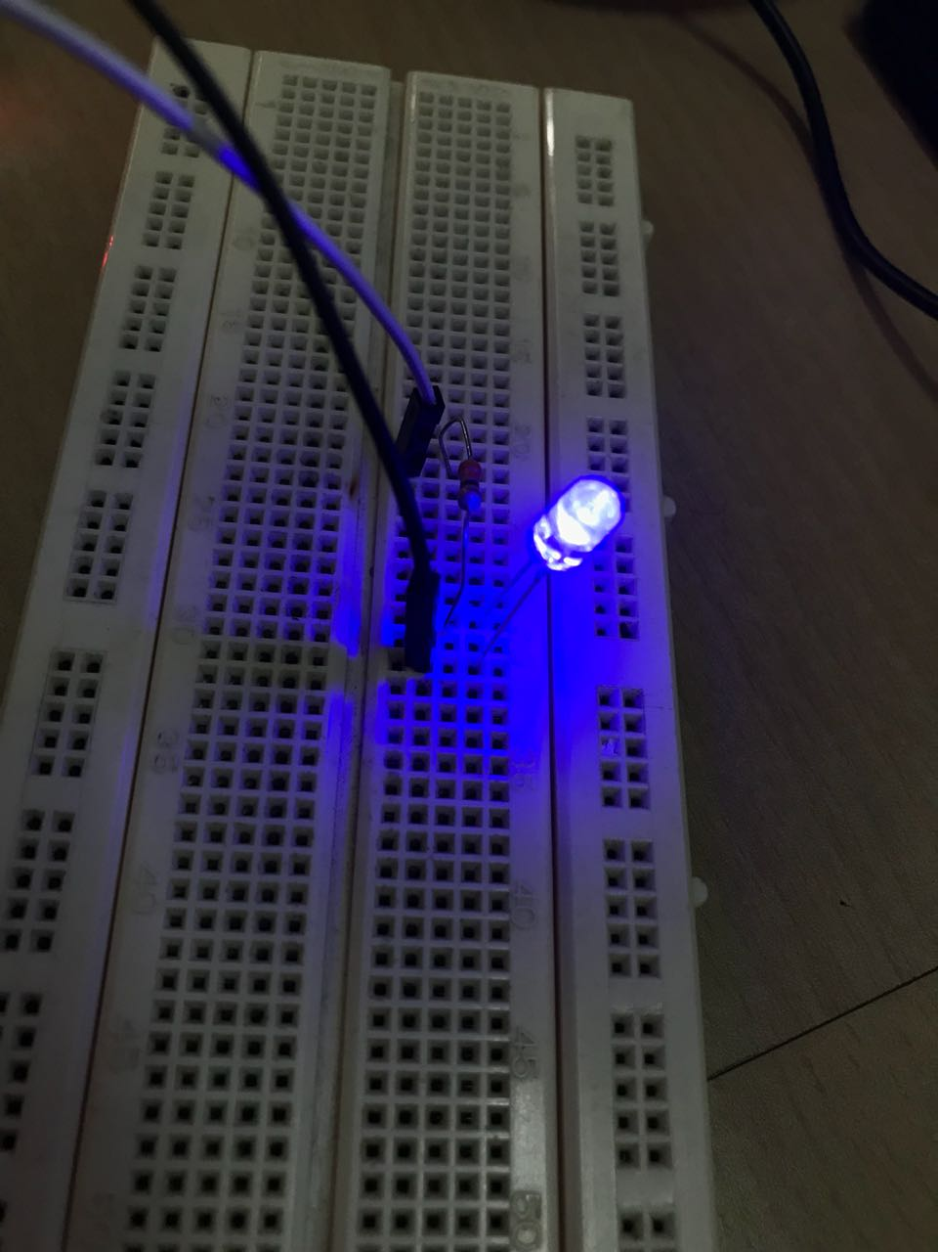

**Write a Python Code to glow an LED on (Using BCM mode) :->**

import time

import RPi.GPIO as GPIO

GPIO.setmode(GPIO.BCM)

GPIO.setup(23, GPIO.OUT)

GPIO.output(23,False)

while True:

GPIO.output(23,False)

**Write a program to blink LED using BOARD mode . Take pin as a input from user :->**

import time

import RPi.GPIO as GPIO

a=int(input(“Enter pin number:”))

GPIO.setwarnings(False)

GPIO.setmode(GPIO.BOARD)

GPIO.setup(a, GPIO.OUT)

GPIO.output(a,True)

while True:

GPIO.output(a, False)

time.sleep(1)

GPIO.output(a, True)

time.sleep(1)

**Write a program to blink LED. Take time as a input from user (using BOARD mode ):->**

import time

import RPi.GPIO as GPIO

a=float(input(“Enter time:”))

GPIO.setwarnings(False)

GPIO.setmode(GPIO.BOARD)

GPIO.setup(11, GPIO.OUT)

GPIO.output(11,True)

while True:

GPIO.output(11, False)

time.sleep(a)

GPIO.output(11, True)

time.sleep(a)

**Write a program to blink the LED number of times requested by user (Using BCM Mode) :->**

import time

import RPi.GPIO as GPIO

GPIO.setmode(GPIO.BCM)

GPIO.setup(23, GPIO.OUT)

GPIO.output(23,True)

y = int (input (“Enter Number of times to blink an LED :”))

for i in range(0,y);

GPIO.output(23,False)

time.sleep(1)

GPIO.output(23,True)

time.sleep(1)

**Write a program to Glow the LED .If condition is satisfied. Take** choice as a **input from user. (Using** if-elif loop**) :->**

import time

import RPi.GPIO as GPIO

GPIO.setwarnings(False)

GPIO.setmode(GPIO.BOARD)

GPIO.setup(8, GPIO.OUT)

GPIO.output(8,True)

y = int (input (“Enter your choice 1.To Glow an LED 2. To switch off an LED 3. To blink an LED:”))

if (y==1):

a=int(input(“Enter a pin number:”))

while True:

GPIO.output(8,True)

elif (y==2):

b=int(input(“Enter a pin number:”))

while False:

GPIO.output(8, False)

elif (y==3):

while True:

c=float(input(“Enter time:”))

GPIO.output(8,True)

time.sleep(c)

GPIO.output(8,True)

time.sleep(c)

**Write a program to blink 3 LED’s 8 times :->**

import time

import RPi.GPIO as GPIO

GPIO.setmode(GPIO.BOARD)

GPIO.setup(7, GPIO.OUT)

GPIO.output(7,True)

GPIO.setup(8, GPIO.OUT)

GPIO.output(8,True)

GPIO.setup(10, GPIO.OUT)

GPIO.output(10,True)

for i in range(1,9);

GPIO.output(7,False)

time.sleep(1)

GPIO.output(7,True)

time.sleep(1)

GPIO.output(8,False)

time.sleep(1)

GPIO.output(8,True)

time.sleep(1)

GPIO.output(10,False)

time.sleep(1)

GPIO.output(10,True)

time.sleep(1)

**Write a program to blink 3 LED’s. Take time as a input from user :->**

import time

import RPi.GPIO as GPIO

a=float(input(“Enter time:”))

b=float(input(“Enter time:”))

c=float(input(“Enter time:”))

GPIO.setwarnings(False)

GPIO.setmode(GPIO.BOARD)

GPIO.setup(8, GPIO.OUT)

GPIO.setup(11, GPIO.OUT)

GPIO.setup(15, GPIO.OUT)

while True:

GPIO.output(8, False)

time.sleep(a)

GPIO.output(8, True)

time.sleep(a)

GPIO.output(11, False)

time.sleep(b)

GPIO.output(11, True)

time.sleep(b)

GPIO.output(15, False)

time.sleep(c)

GPIO.output(15, True)

time.sleep(c)

The output look like below image :

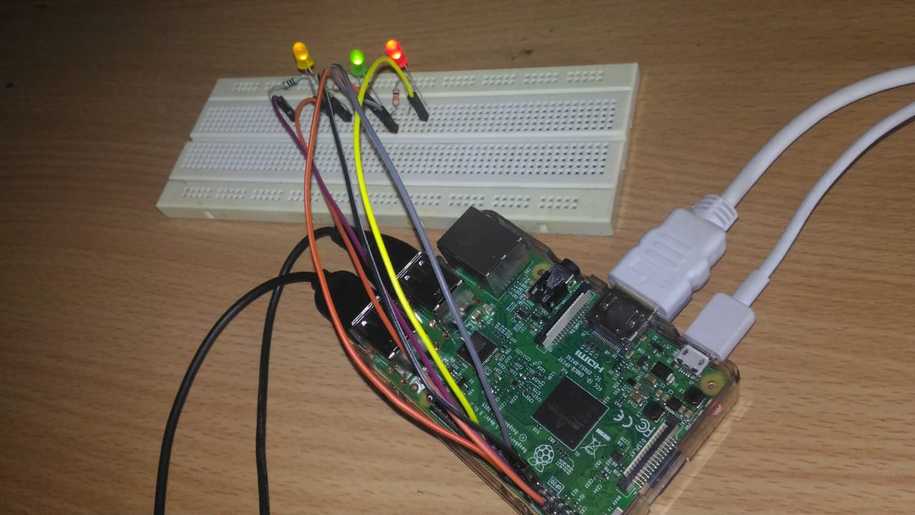

**Practical 5:**

**AIM: Run the node red editor and run simple programs and trigger GPIO. Use basic nodes such as inject, debug, GPIO.**

**1.Copy the below given link**

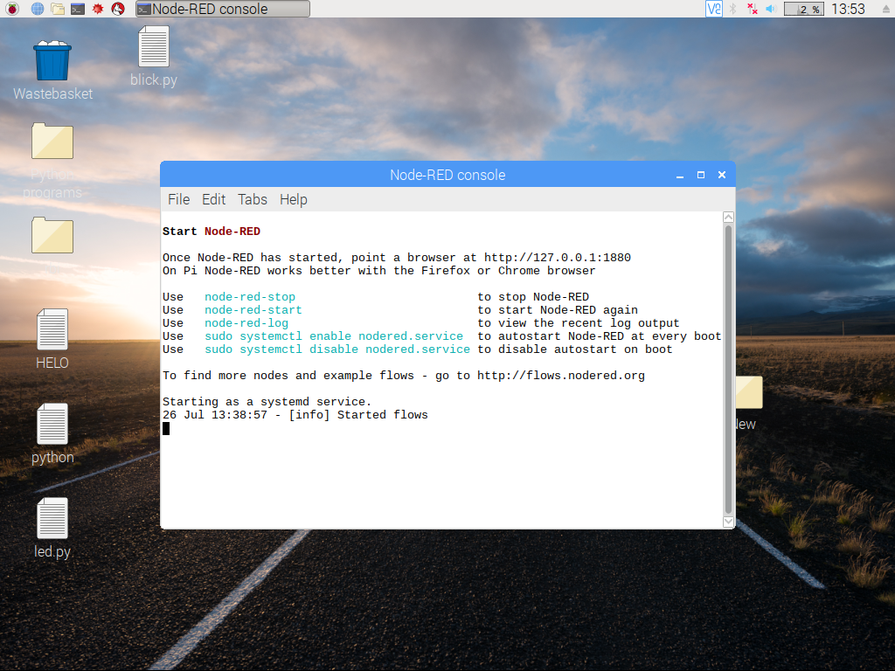

1. **Paste it in the browser**

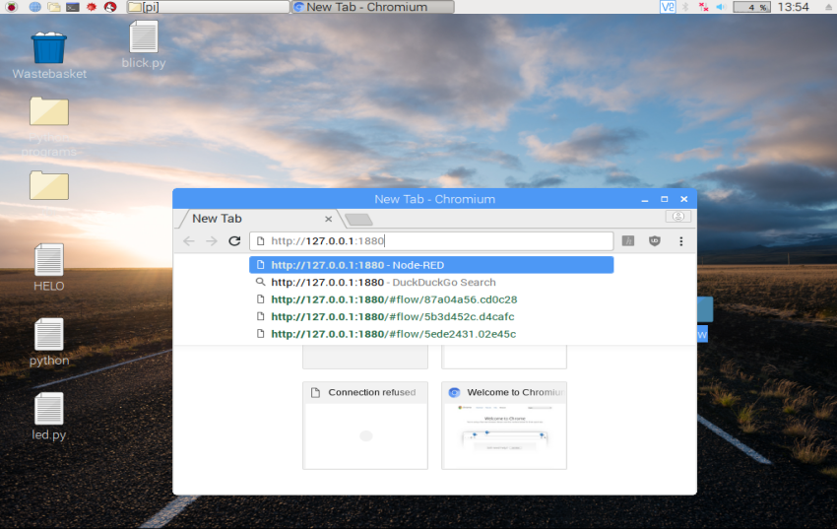

1. **There are some readymade functions given in node red Eg:Change function. Create a flow as given below**

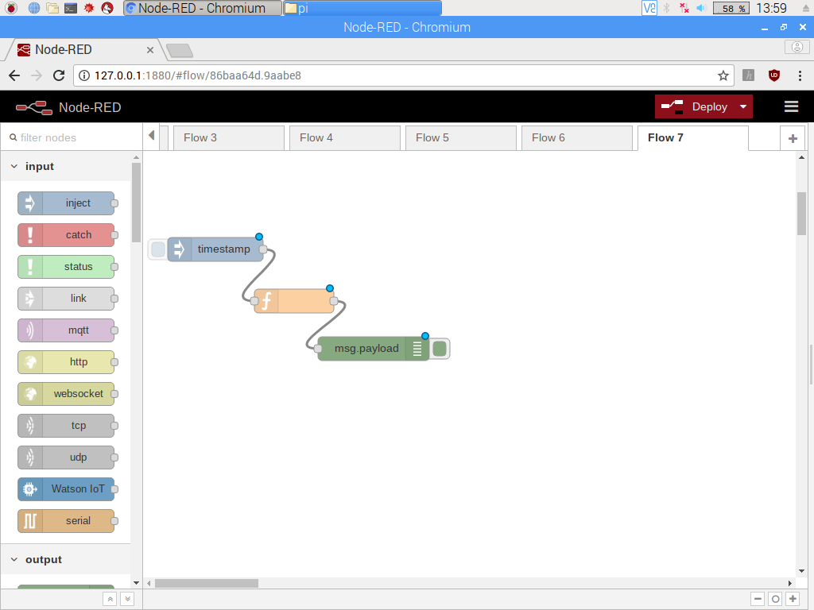

1. **Double click on time stamp and write it as “Hello World” in payload**

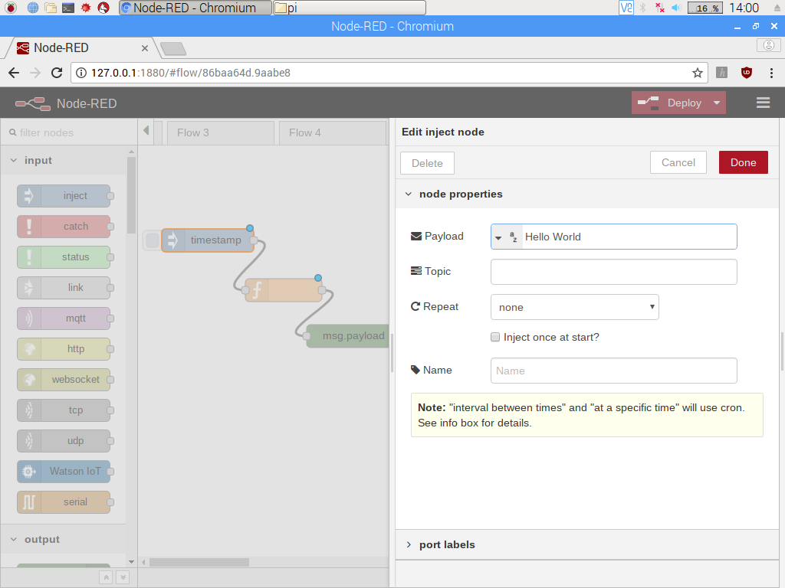

1. **Double click on change function and search for “world” and replace with “From Nodered”.**

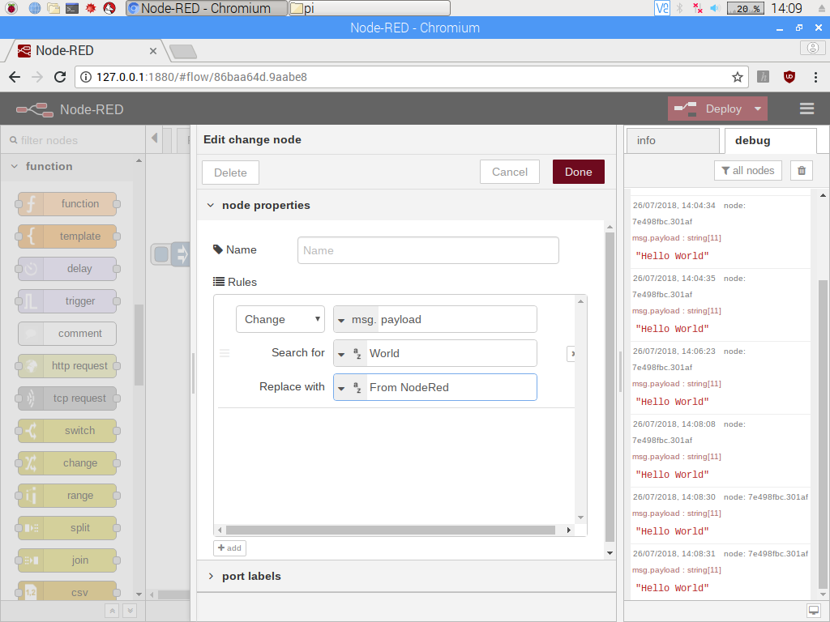

**6.Then deploy and check the result.**

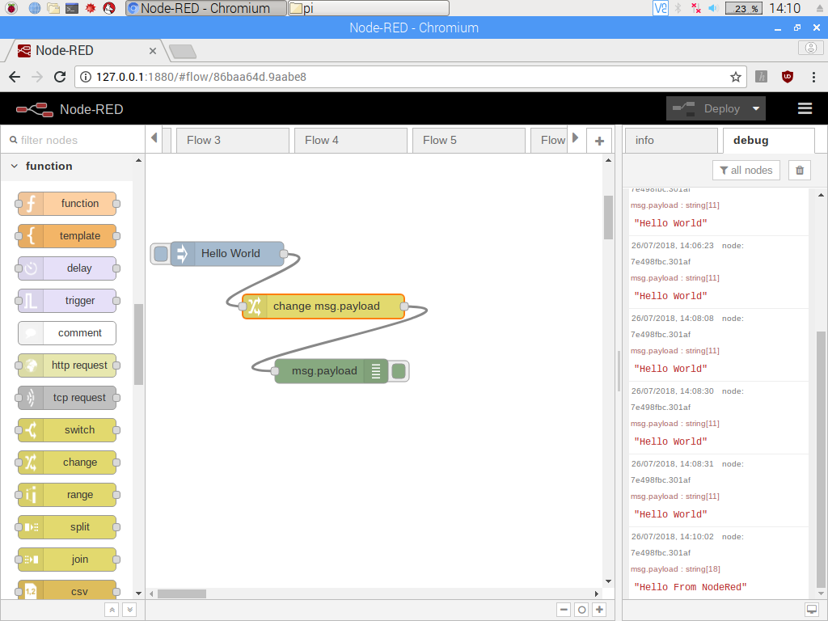

1. **By using self declared functions(change function): Create a similar flow as above but instead of using readymade change function use a simple function**



**8. Double click on time stamp and write it as “Hello World” in payload**

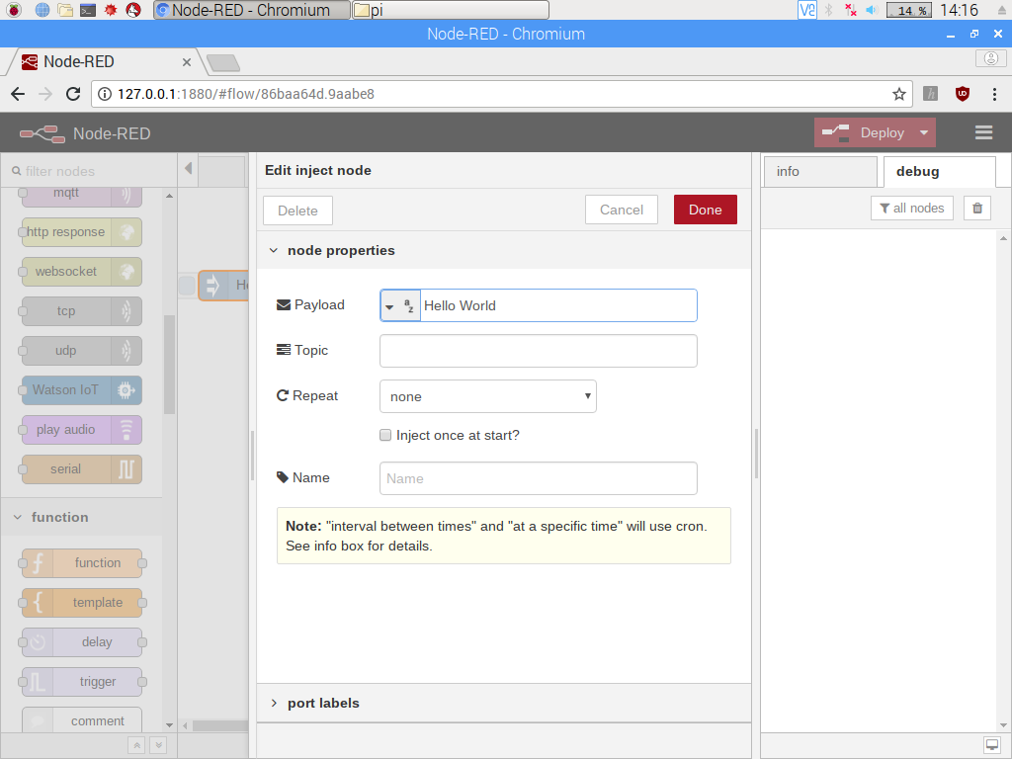

1. **Double click on function and write the below code**

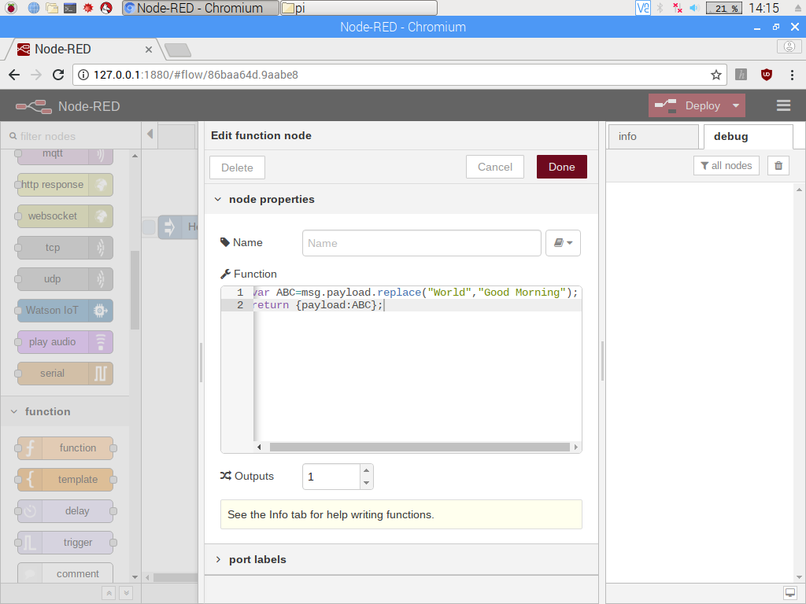

1. **Deploy and check the output**

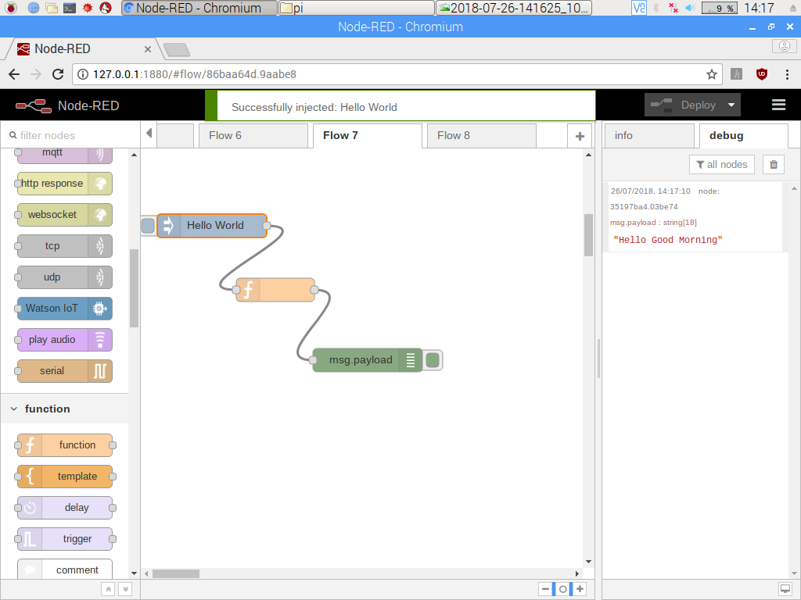

1. **Function to reduce the number by 2. Create the flow as below**



1. **Double click the function and write the code given below:**

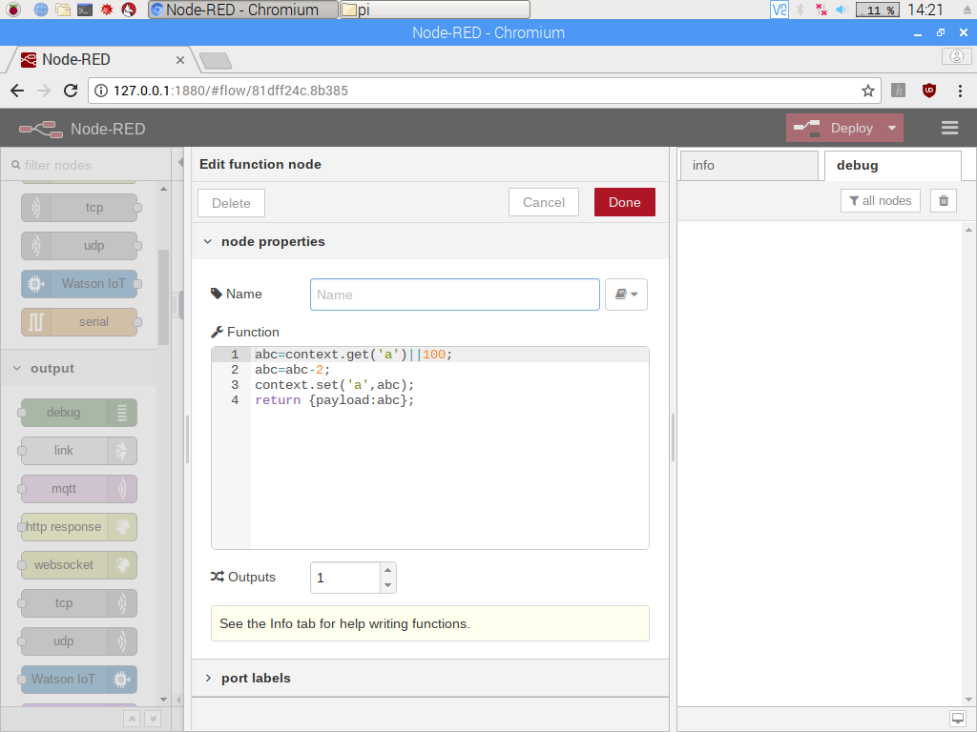

1. **Then deploy and check the output**

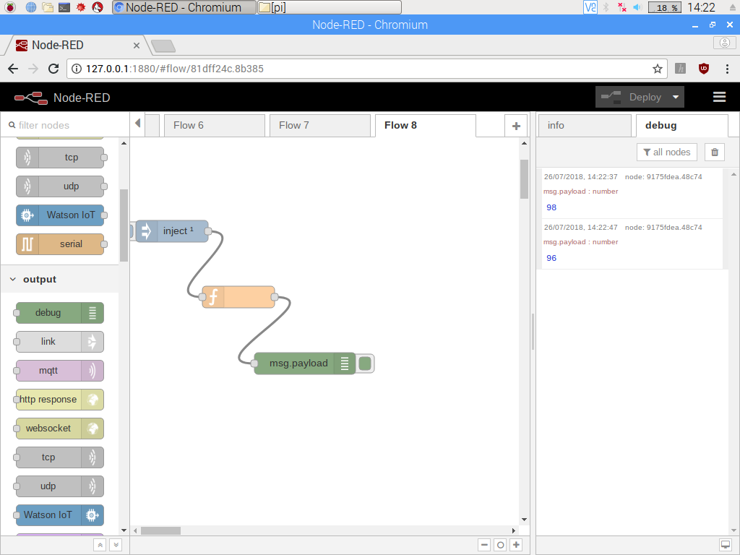

1. **Function to display even numbers. Create the flow as below**



1. **Double click the function and write the code given below:**

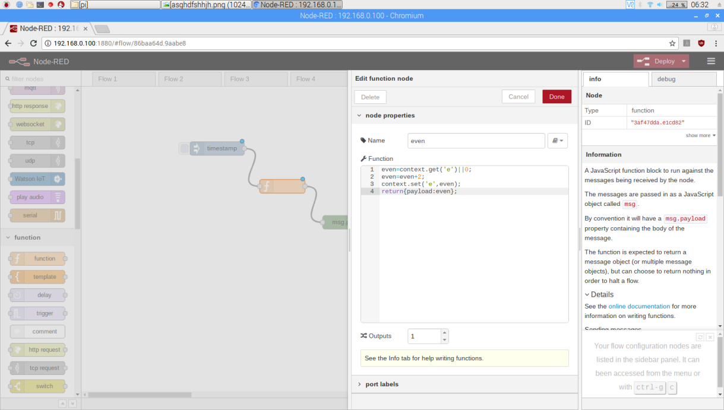

1. **Deploy and check the output.**

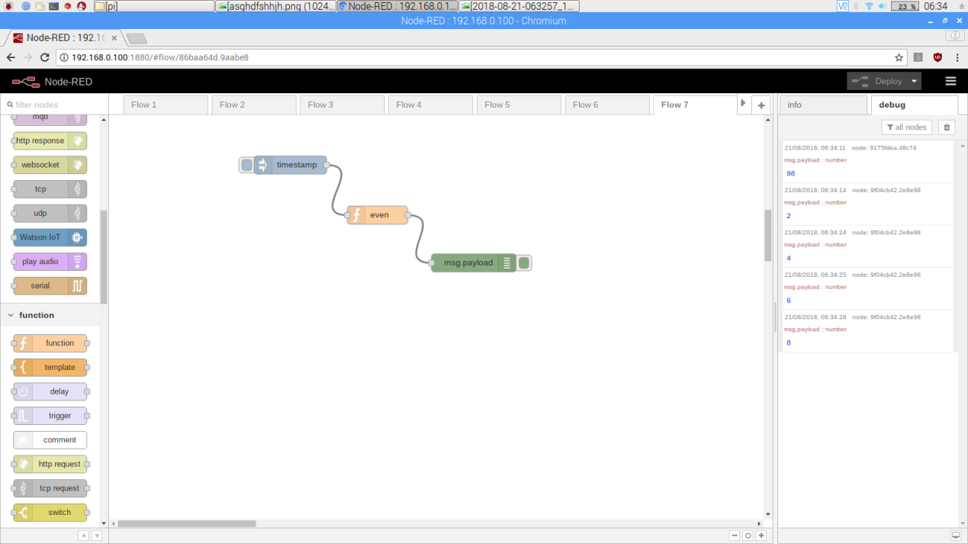

1. **Function for adding two numbers. Create the flow as given below.**

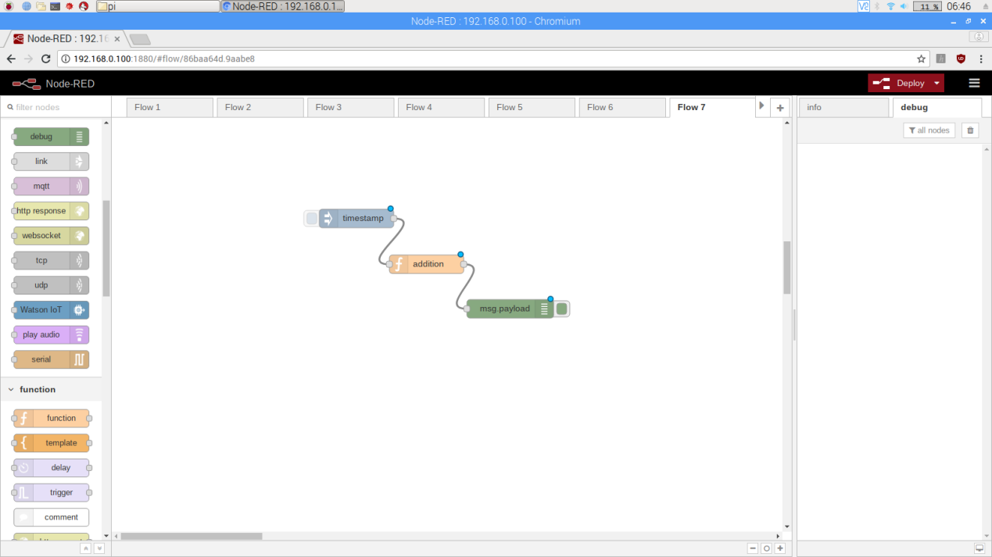

1. **Double click the function and write the below given code**

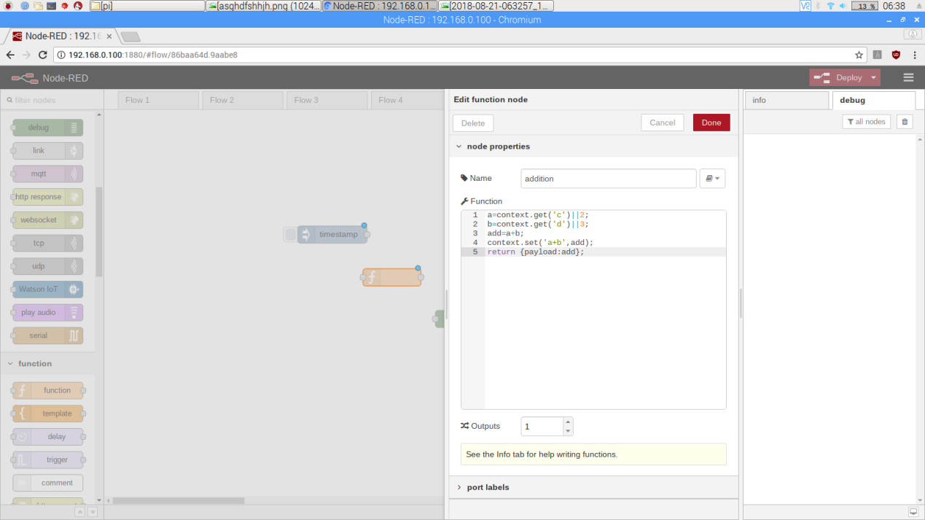

1. **Deploy and check the output.**

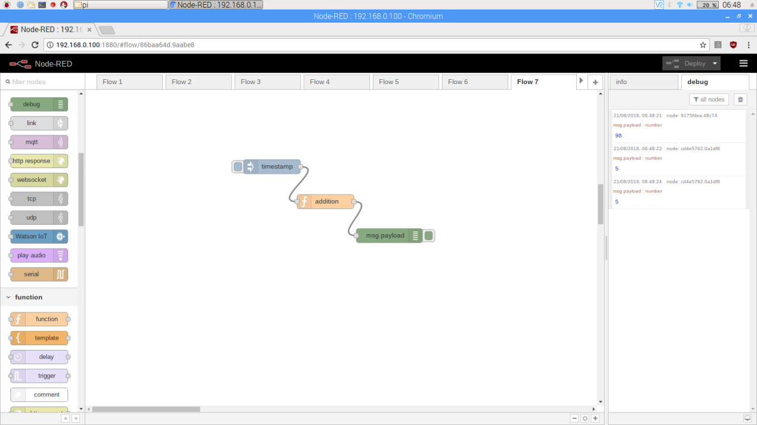

1. **Function to subtract 2 numbers. Create the flow as given below.**



1. **Double click the function and copy the code.**

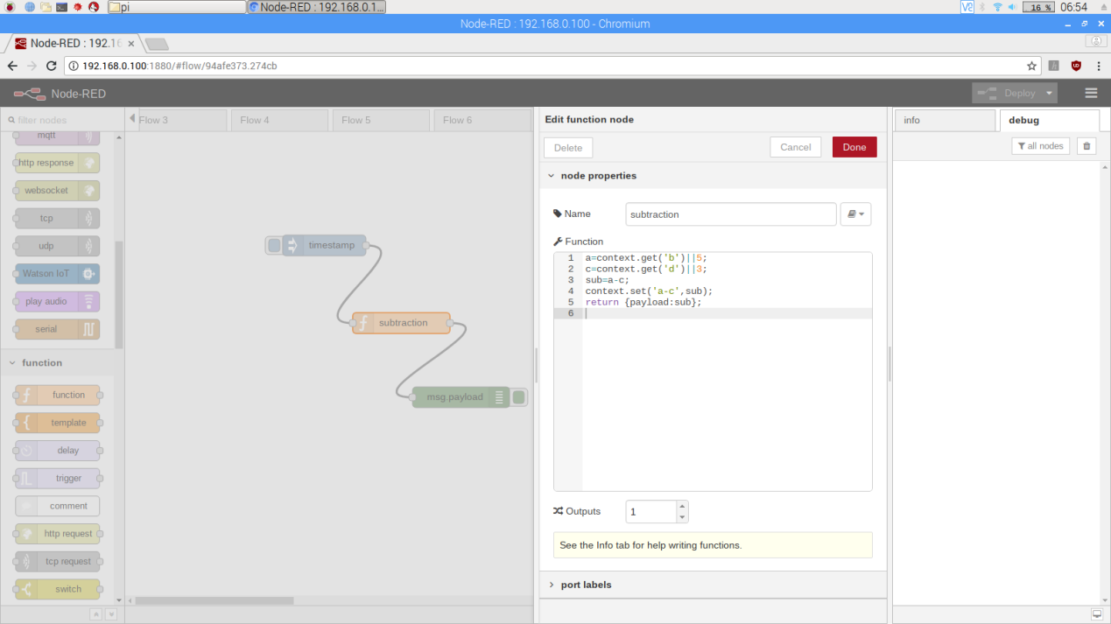

1. **Deploy and check the output.**

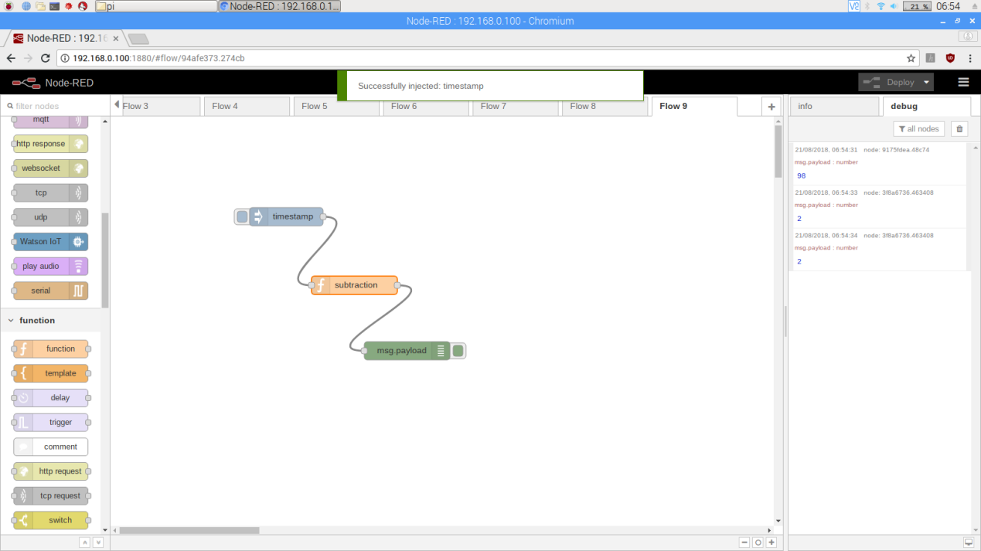

1. **Function for multiplying 2 numbers. Create the flow as given below.**

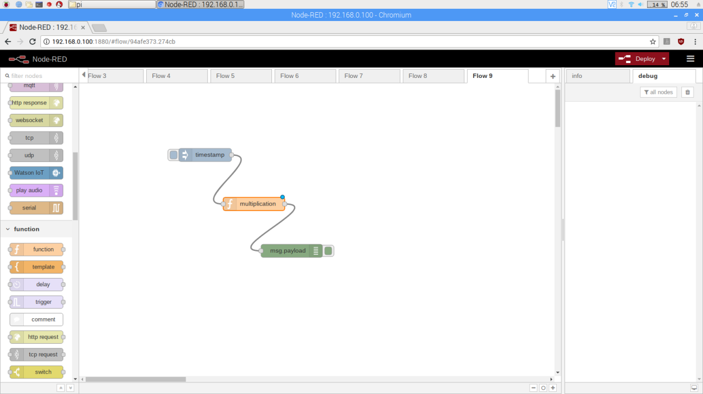

1. **Double click the function and write the below code.**

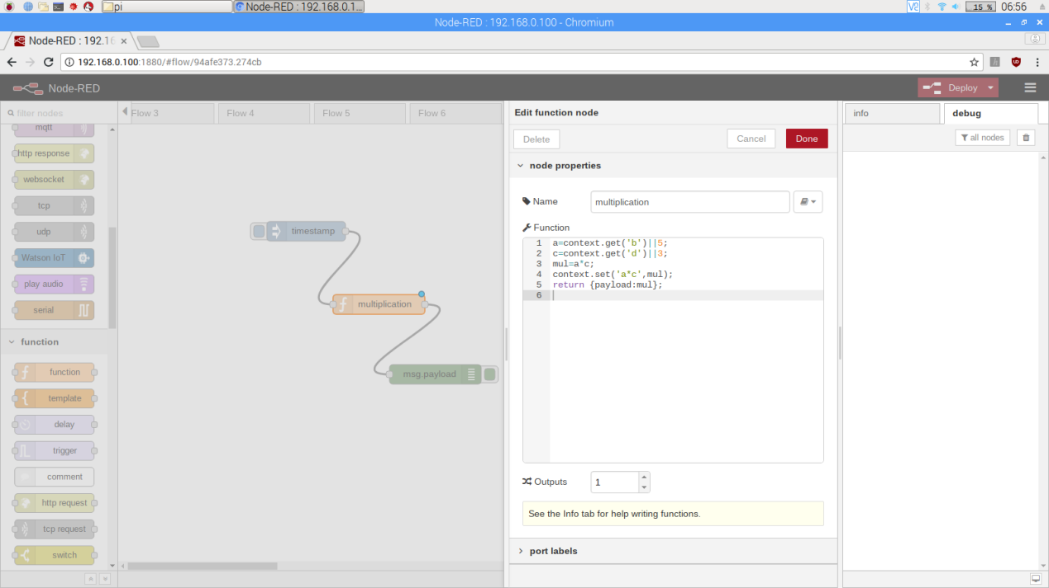

1. **Deploy and check the result.**

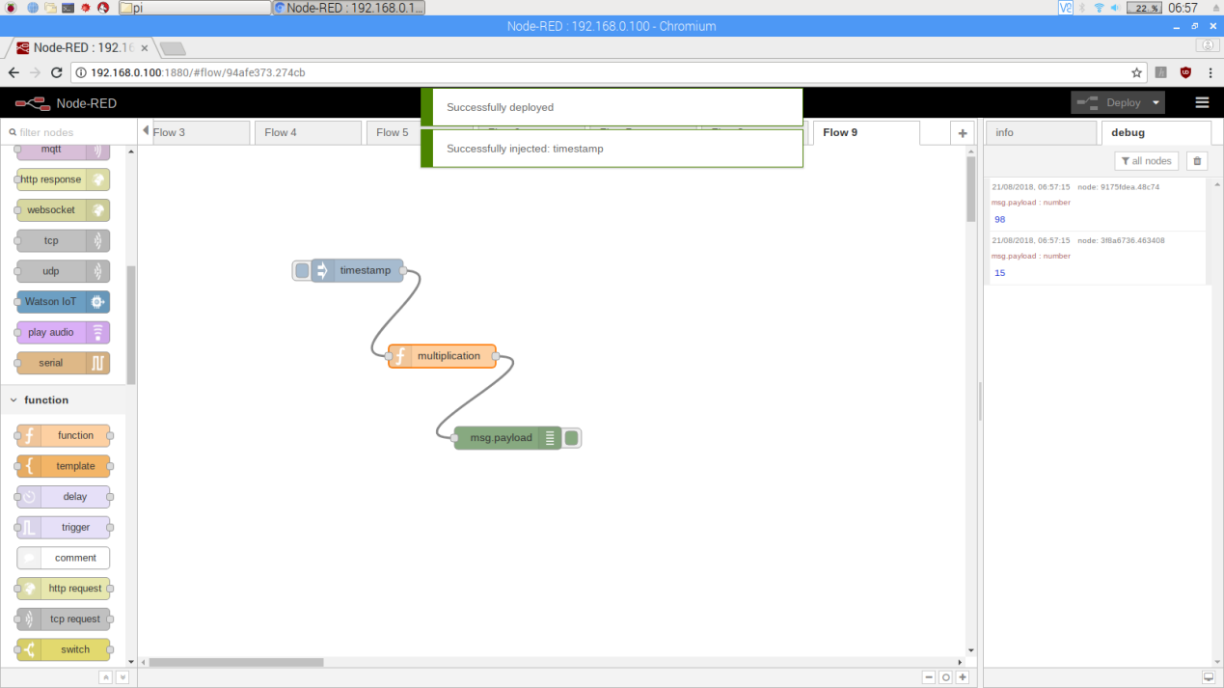

1. **Function for dividing 2 numbers. Create the flow as given below.**

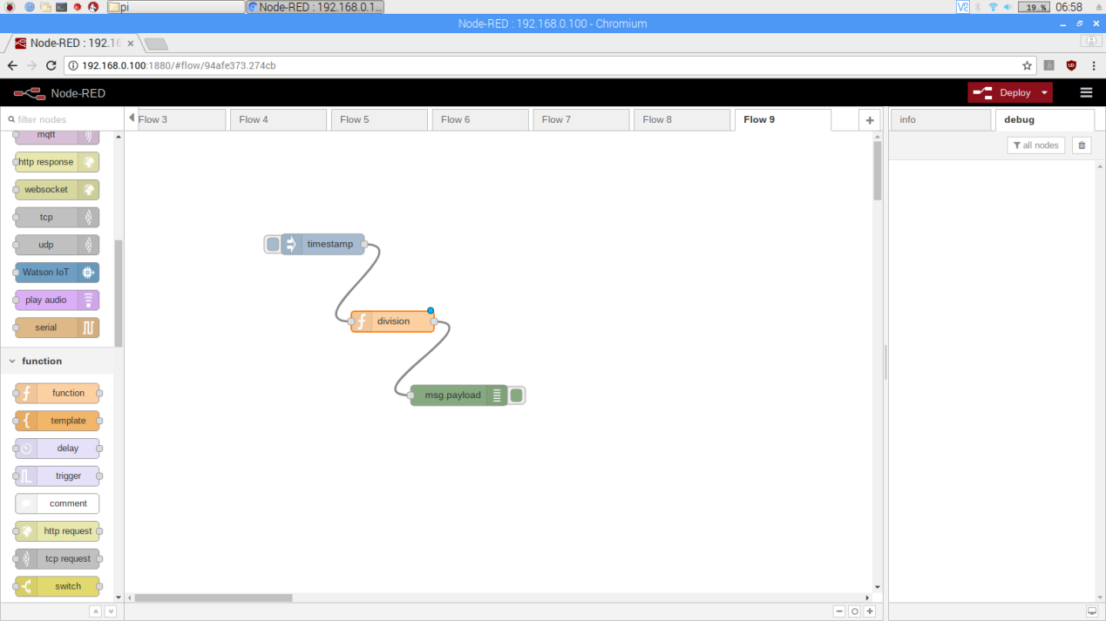

1. **Double click the function and write the below code.**

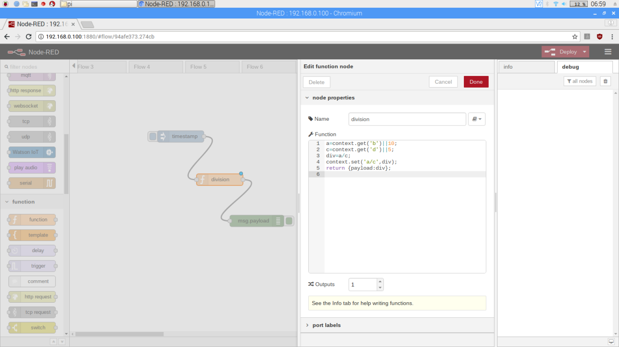

1. **Deploy and check the output.**

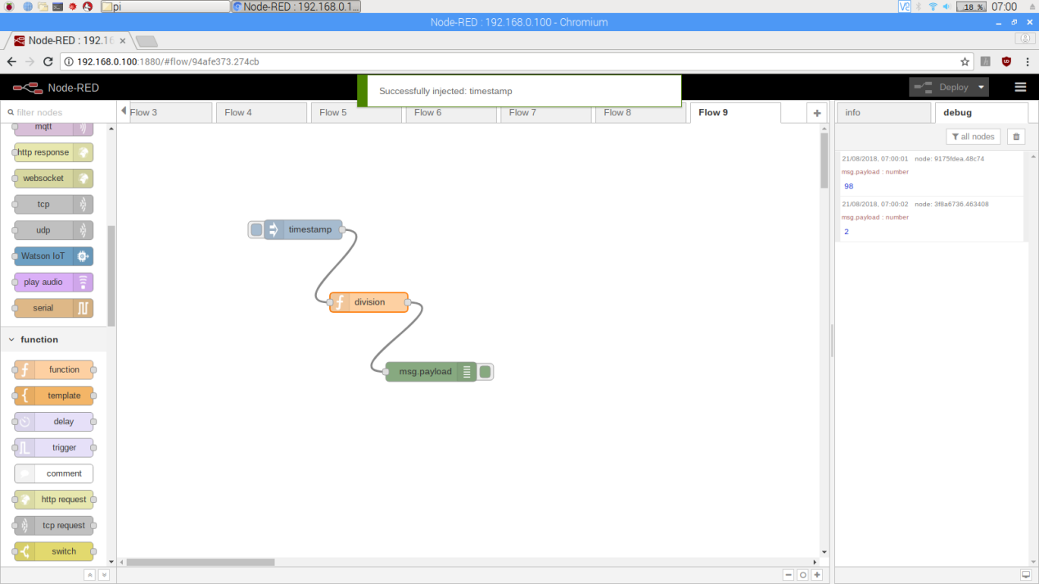

1. **Function for generating odd numbers . Create the flow as given below.**

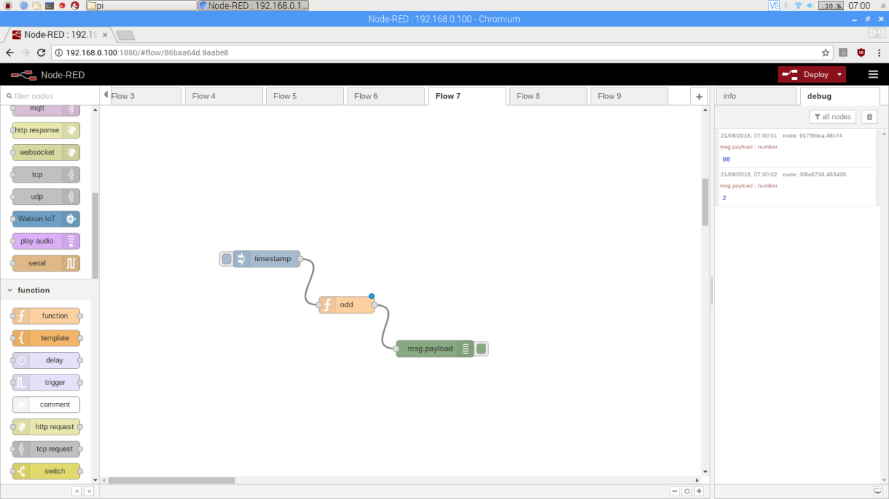

1. **Double click the function and write the below code.**

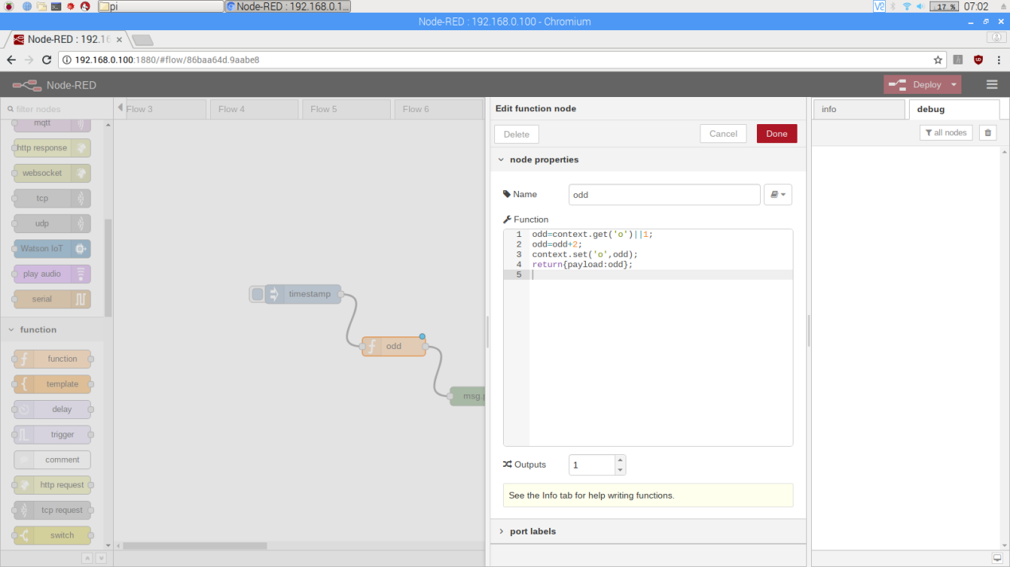

1. **Deploy and check the result.**

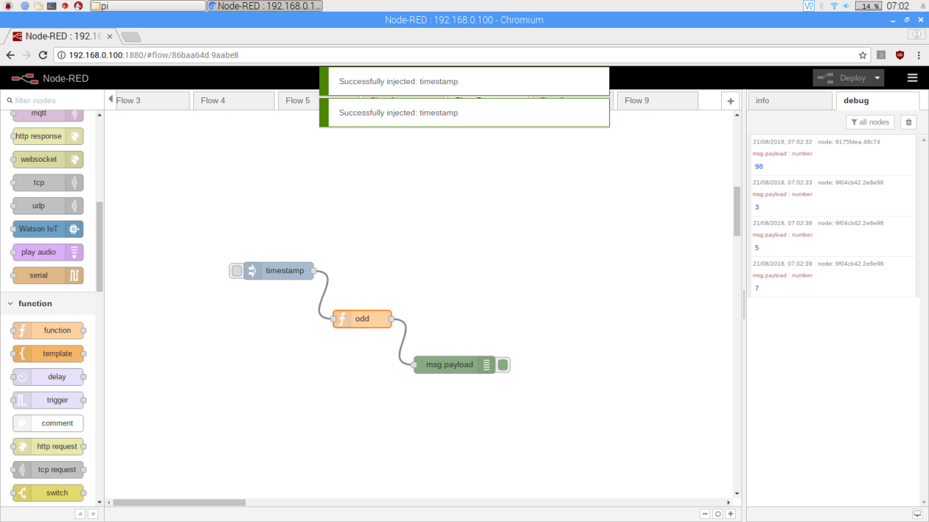

1. **Function for random numbers. Create the flow given below by taking inbuilt random function.**

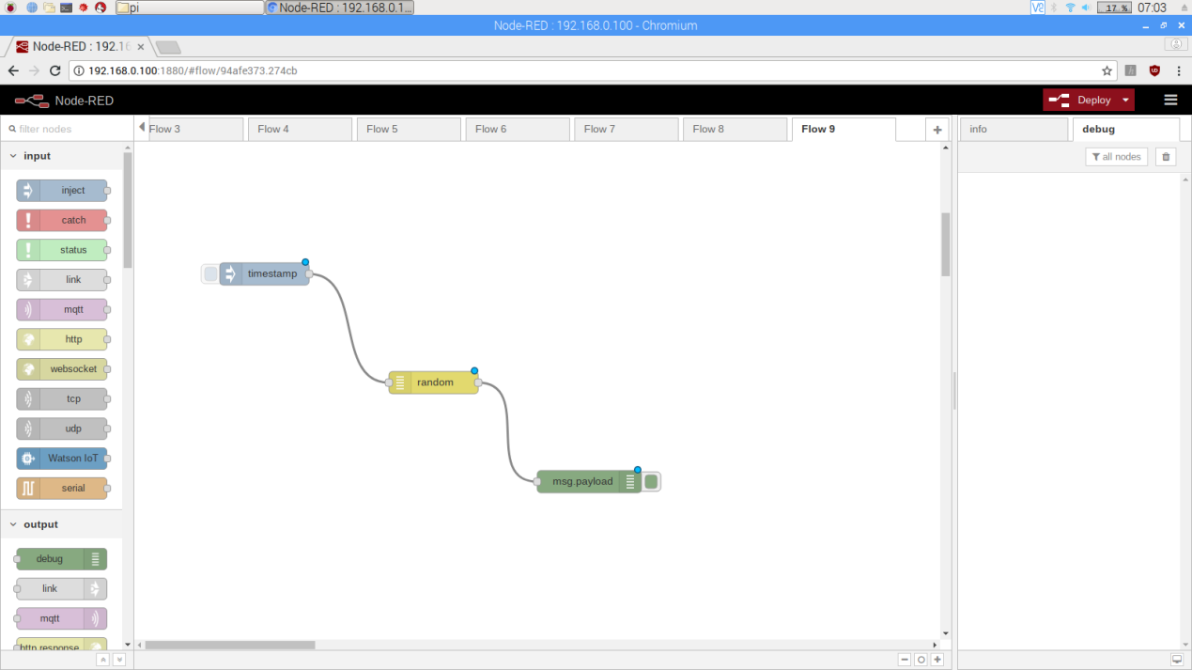

1. **Double click the random function and make changes as given below.**

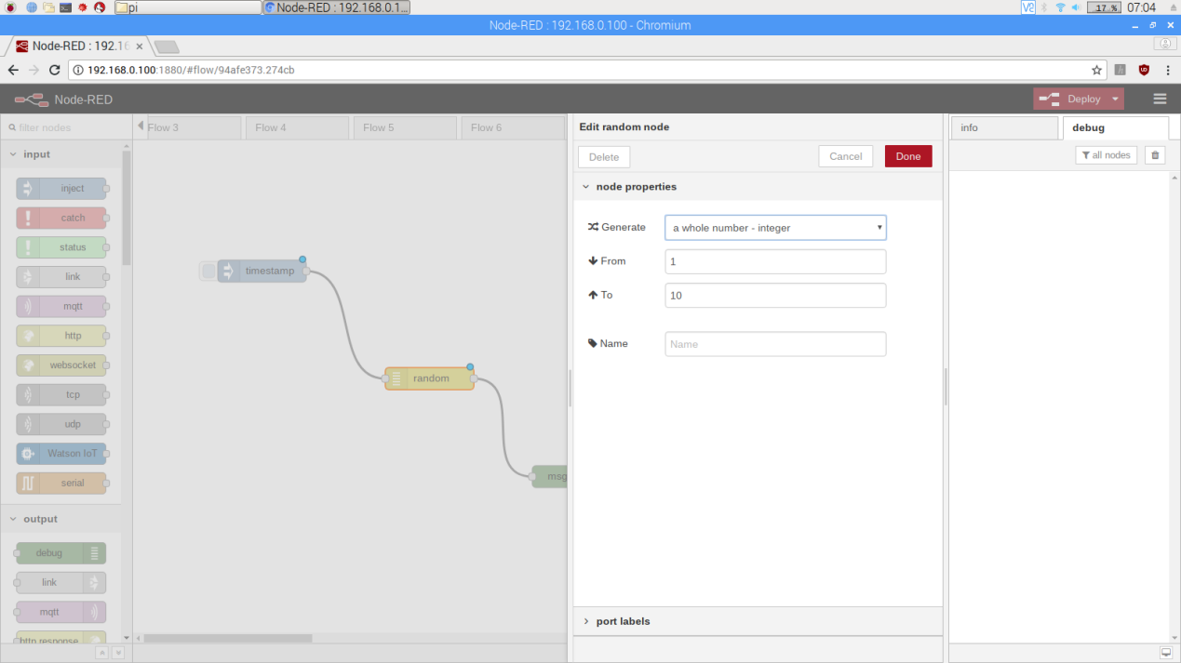

1. **Deploy and check the output.**

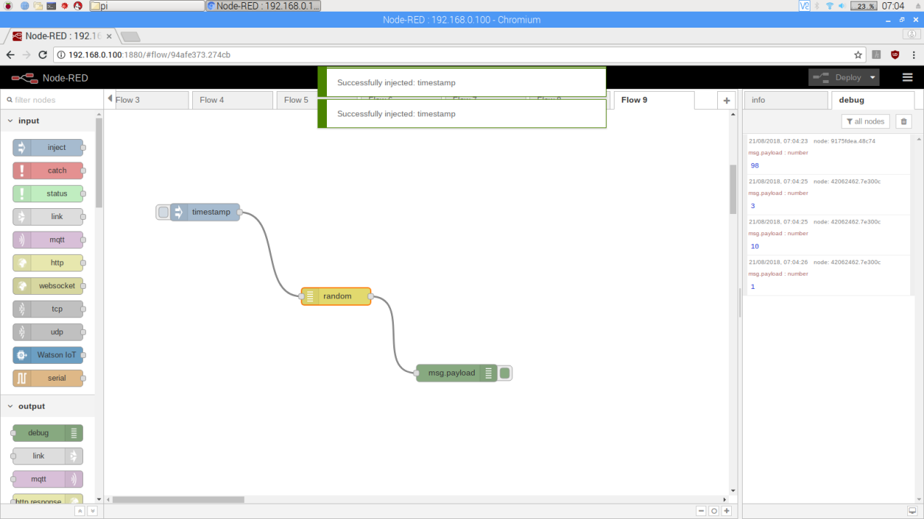

1. **Function to get numbers with interval 5. create the flow as given below.**

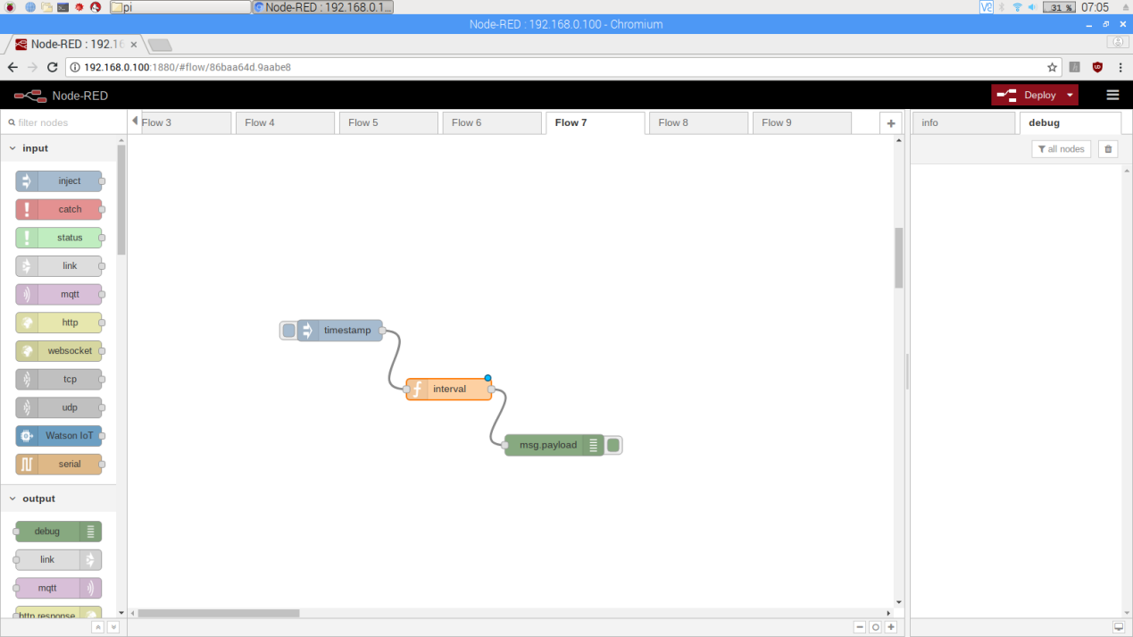

1. **Double click the function and write the code as below.**

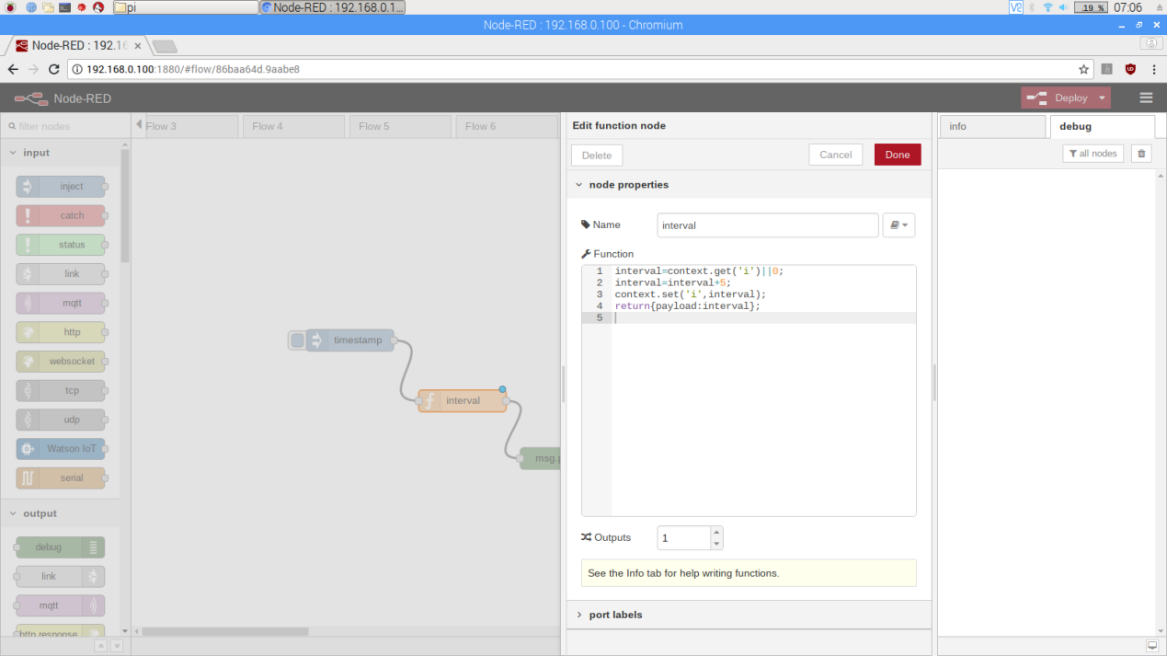

1. **Deploy and check the output.**

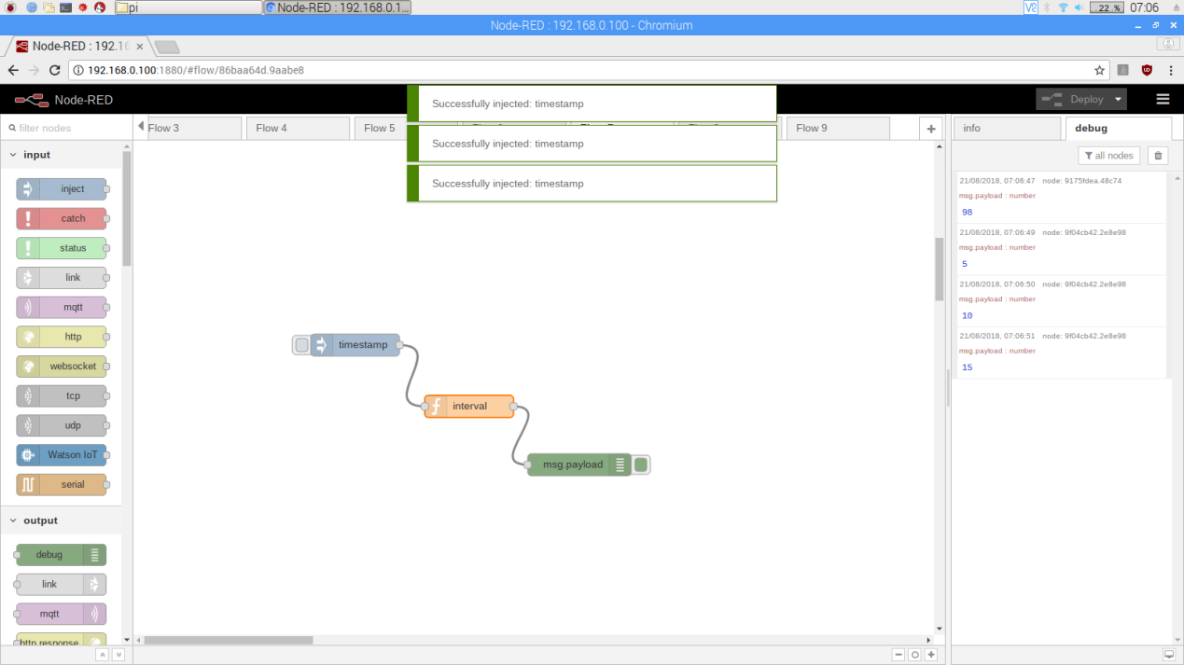

1. **Function to print message “congrats” if marks are equal to 70. Create the flow as given below.**

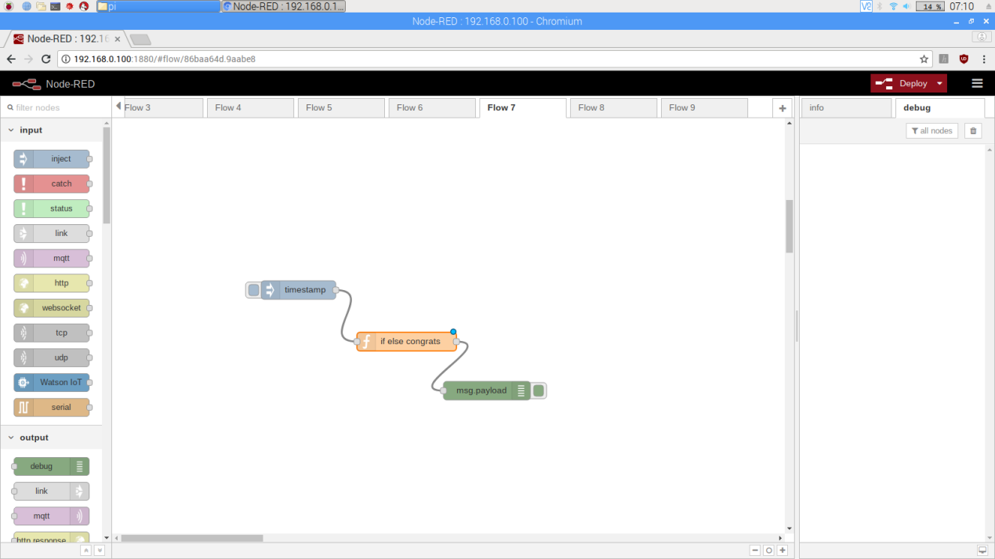

1. **By double clicking the function Write the code as given below.**

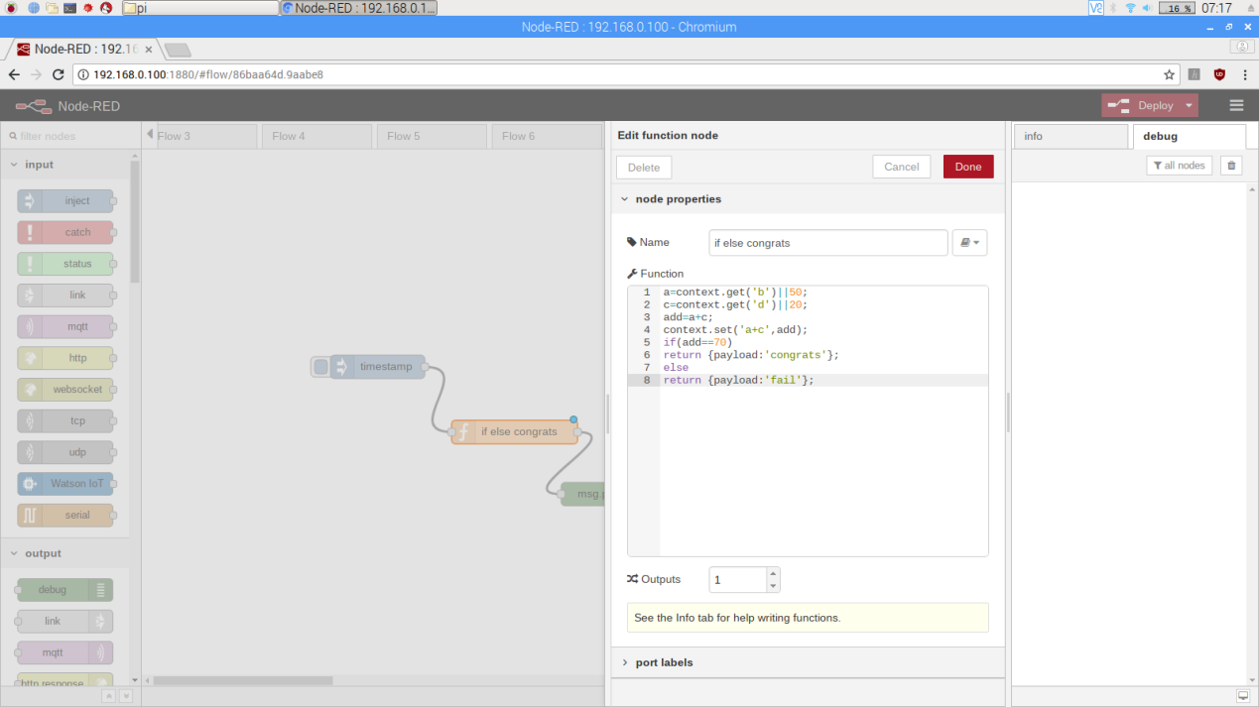

1. **Deploy and check the output.**

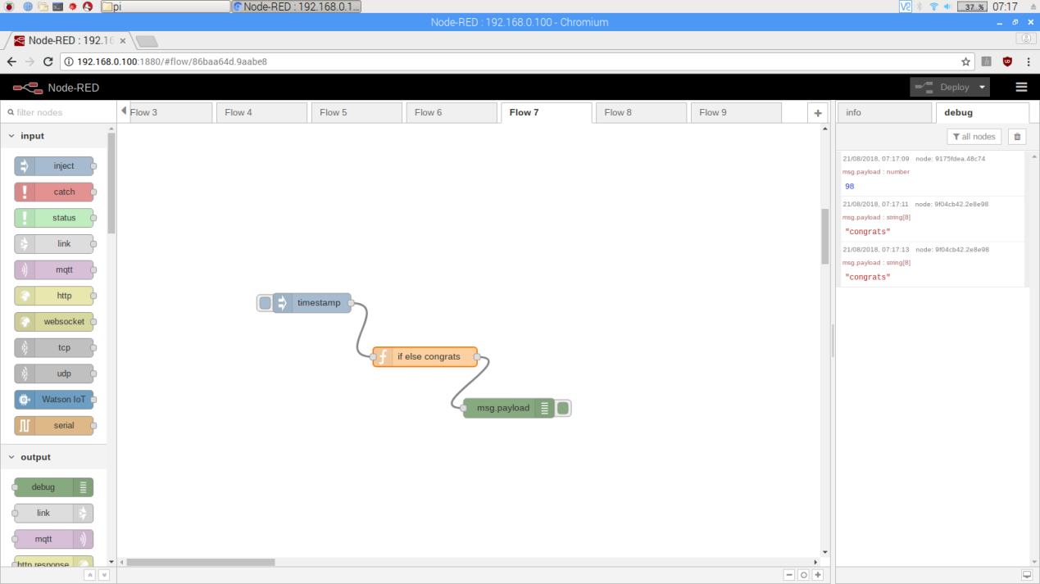

1. **Function to calculate area of square. Create flow as given below**

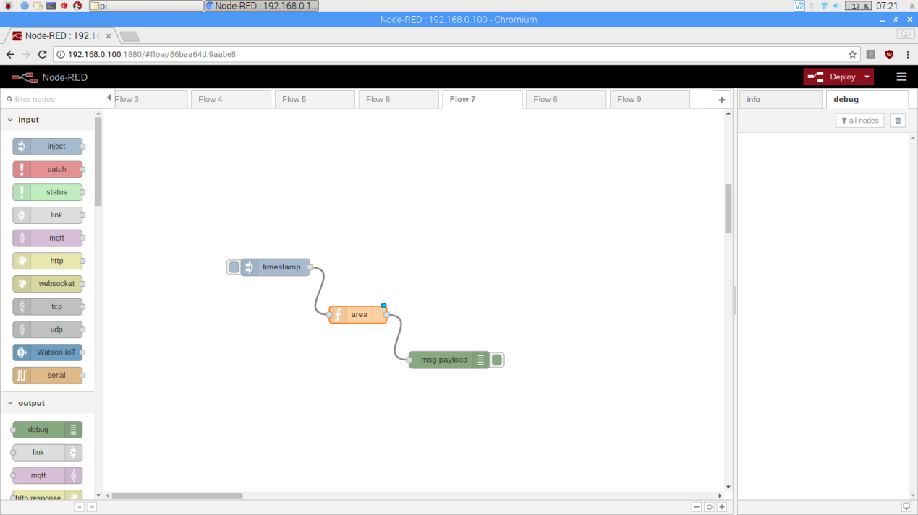

1. **Double click the function and write the code.**

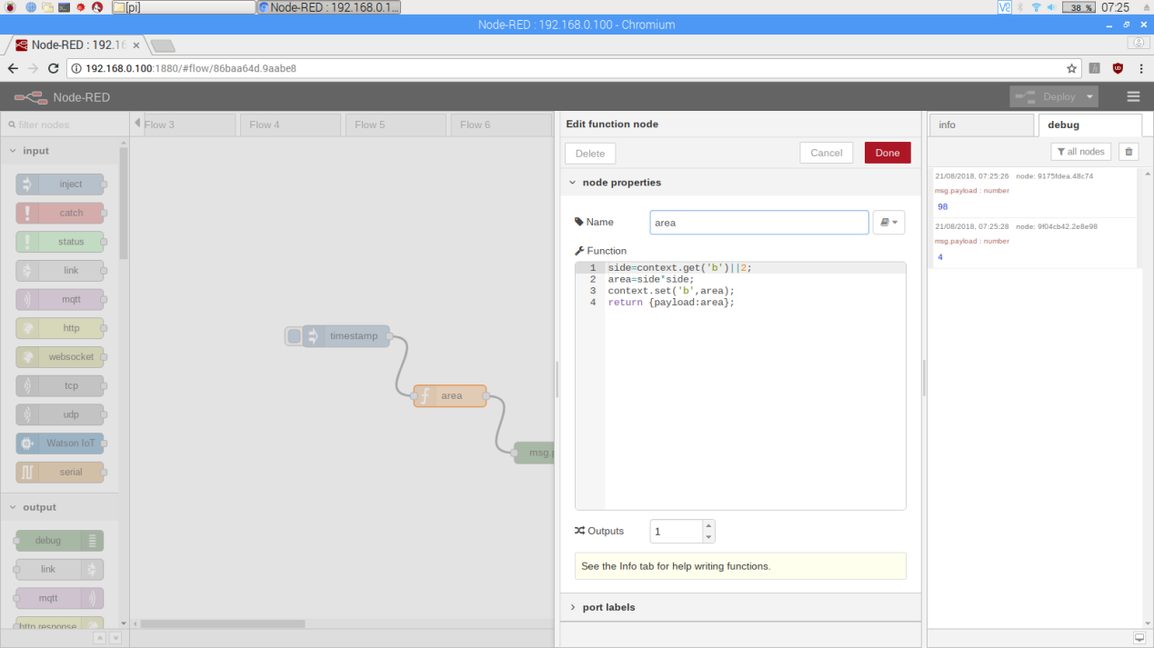

1. **Deploy and check the result.**

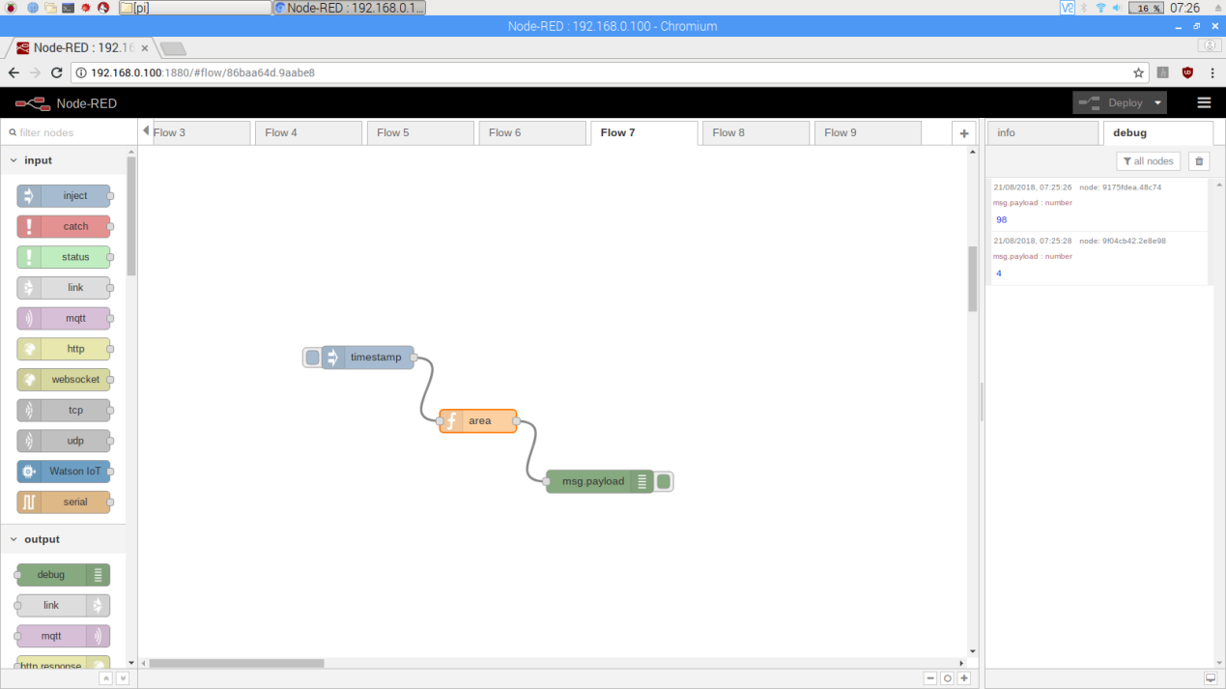

1. **Function to calculate area of circle. Create the flow as given below.**

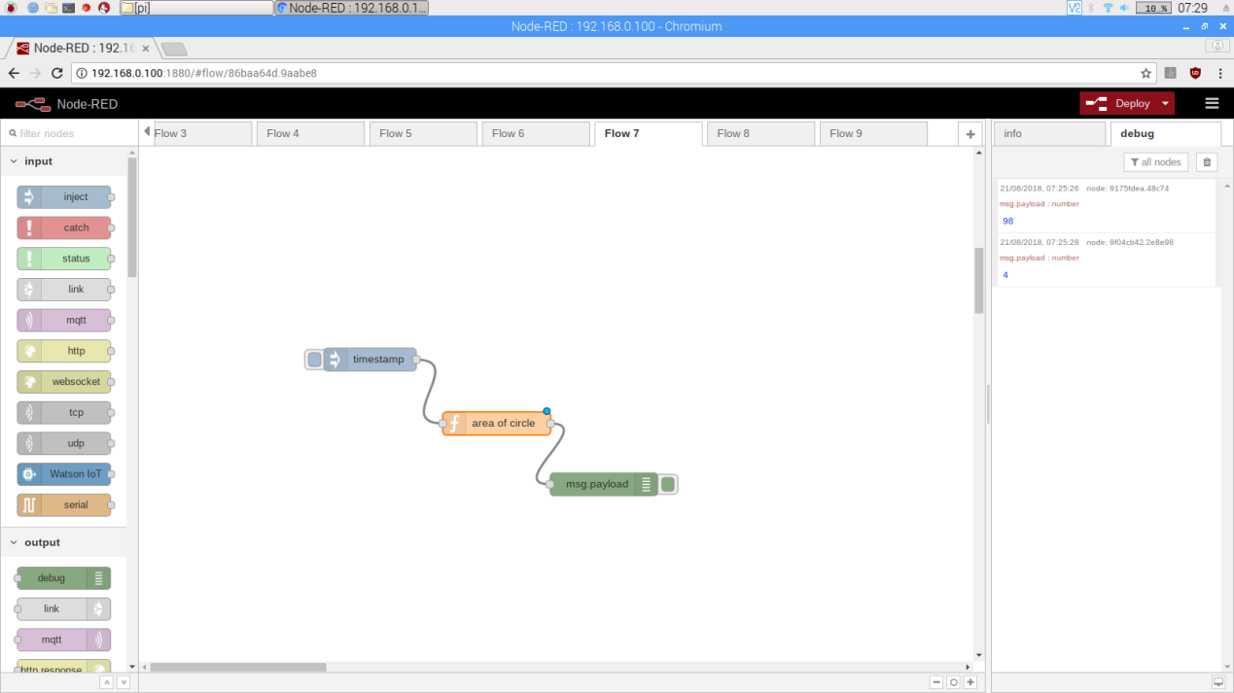

1. **Double click the function and write the below code.**

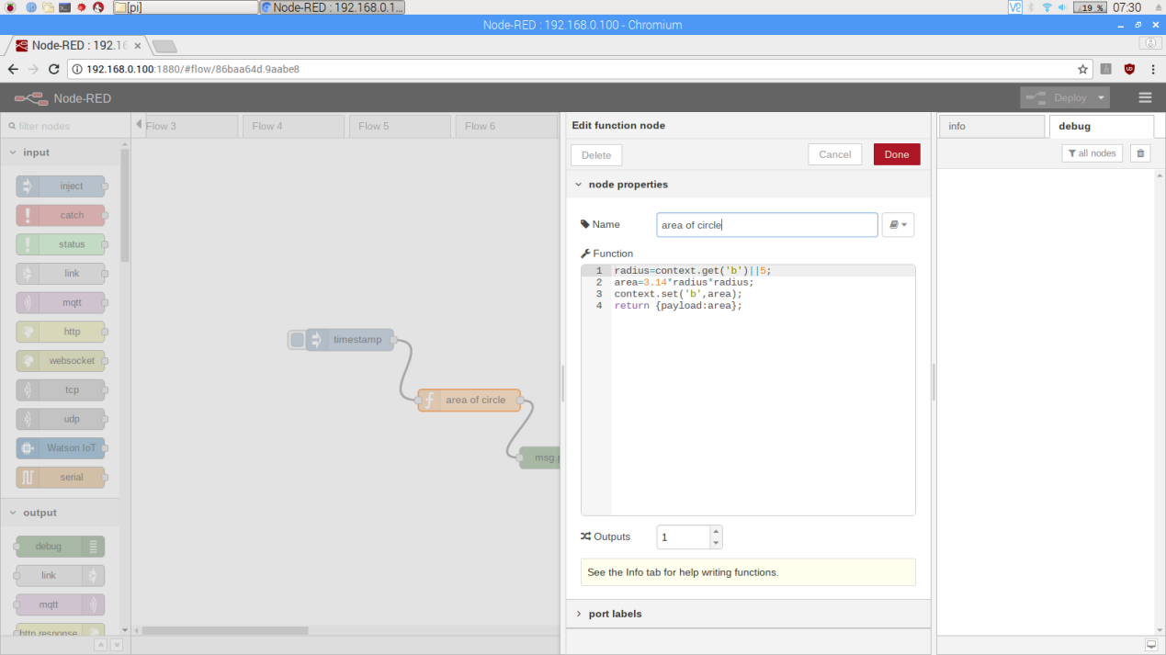

1. **Deploy and check the output.**

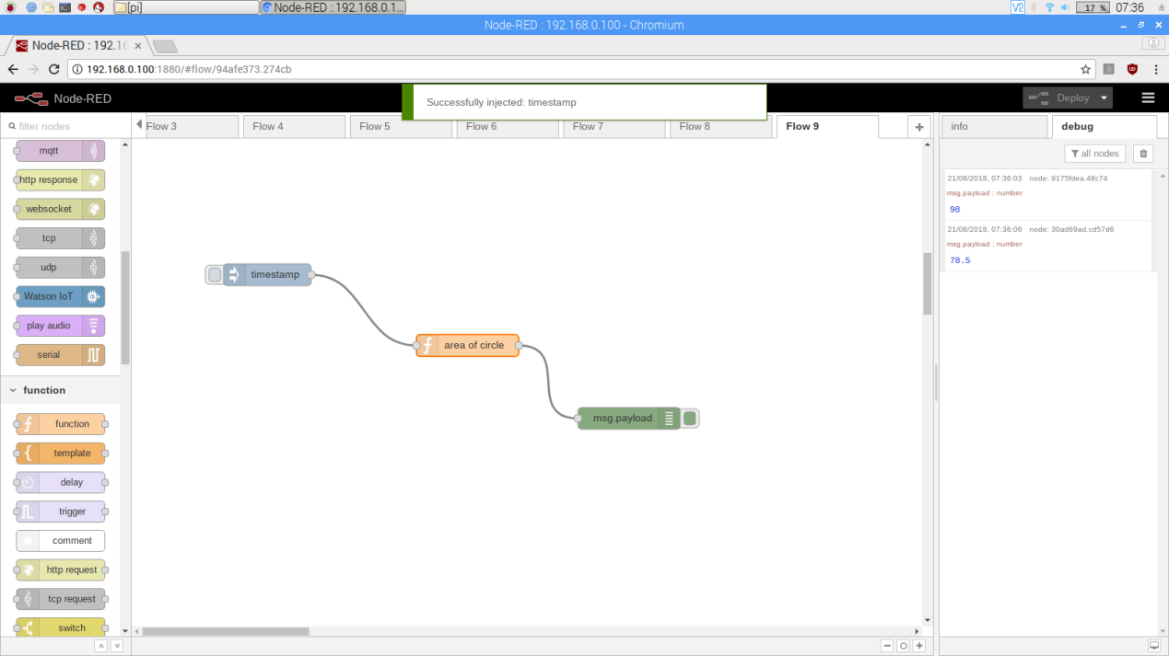

1. **Function to calculate the area of triangle. Create the flow as given below.**

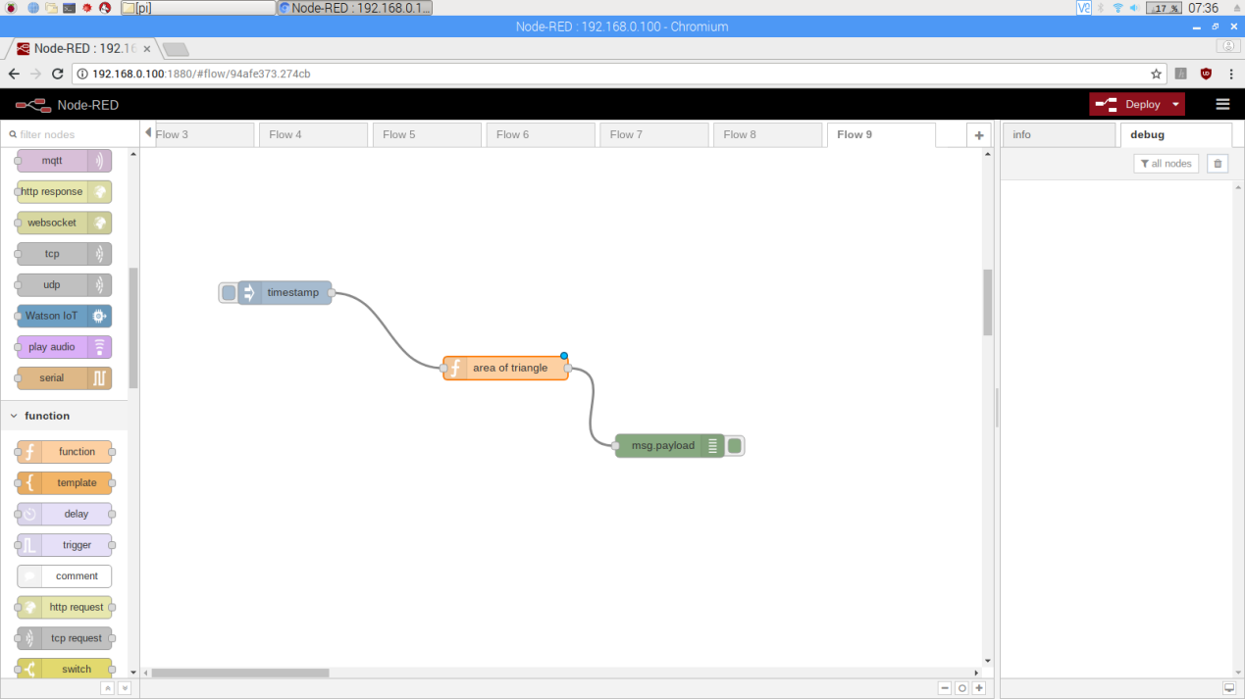

1. **Double click the function and add the code .**

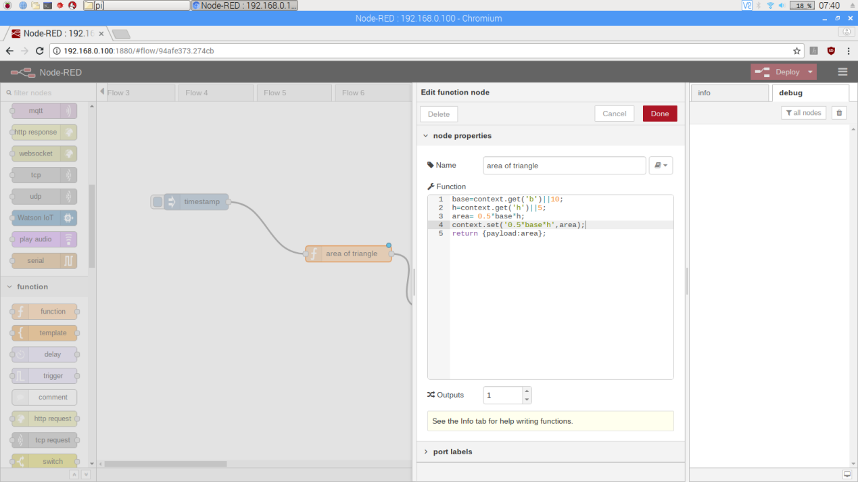

1. **Deploy and check the result.**

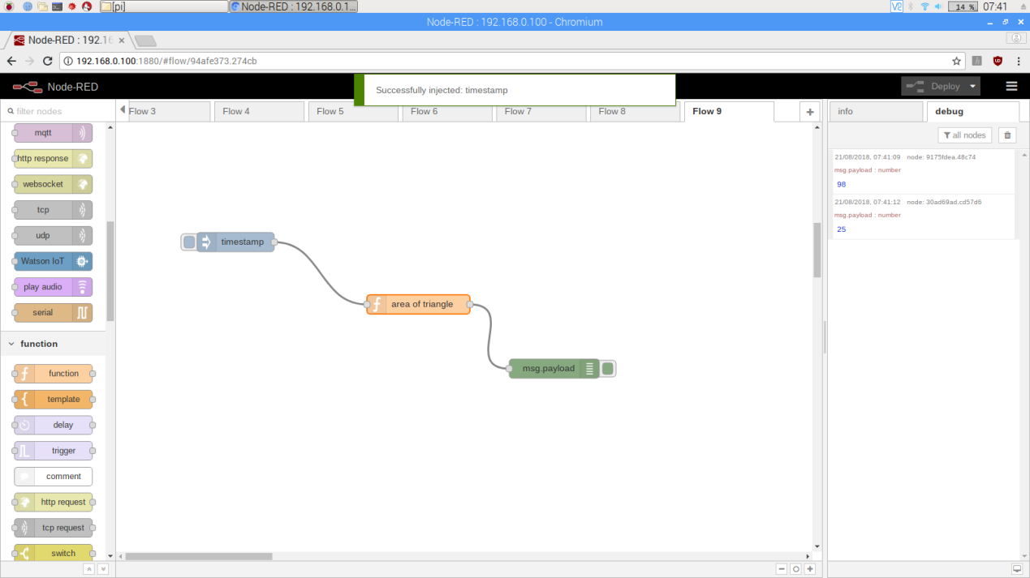

1. **Function to calculate the perimeter of triangle. Create the flow as given below.**

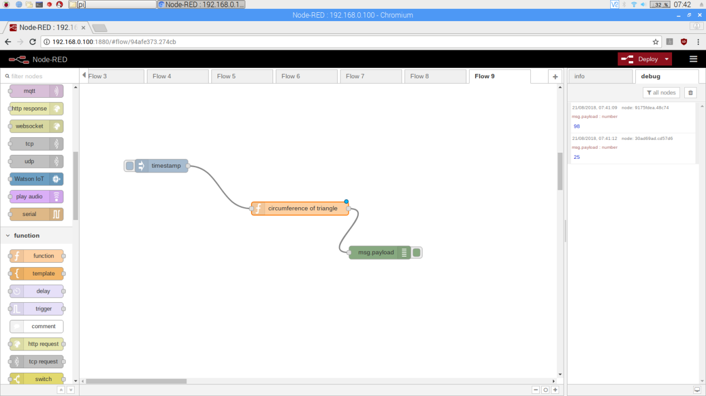

1. **Double click the function and add the code given below.**

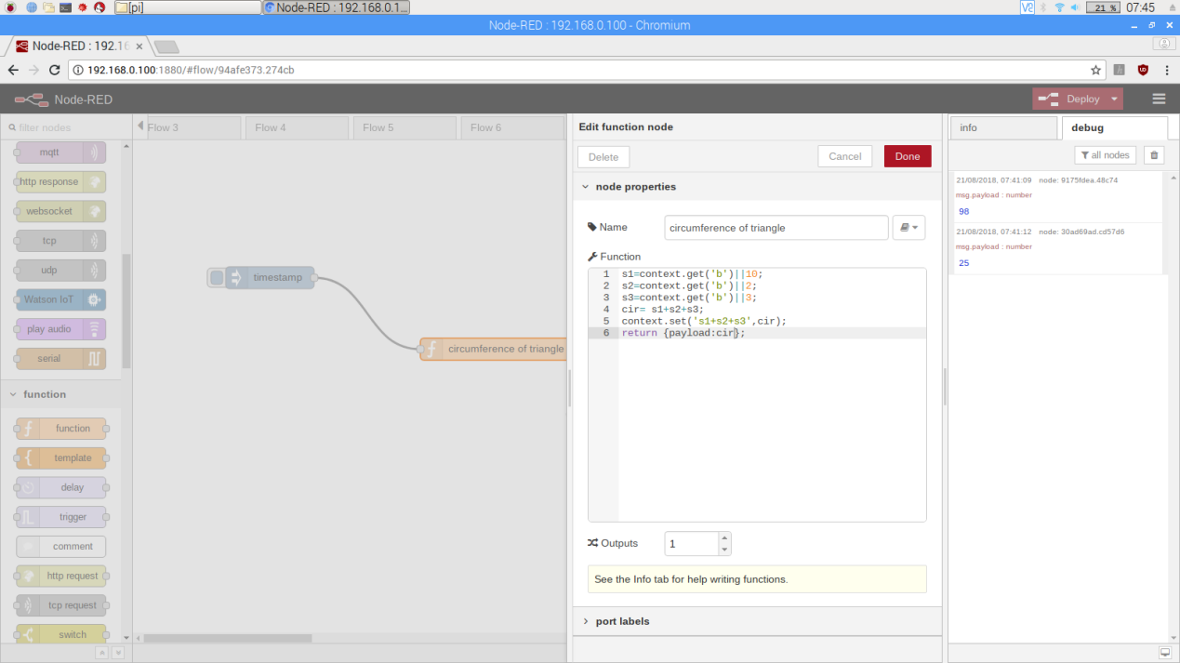

1. **Deploy and check the output.**

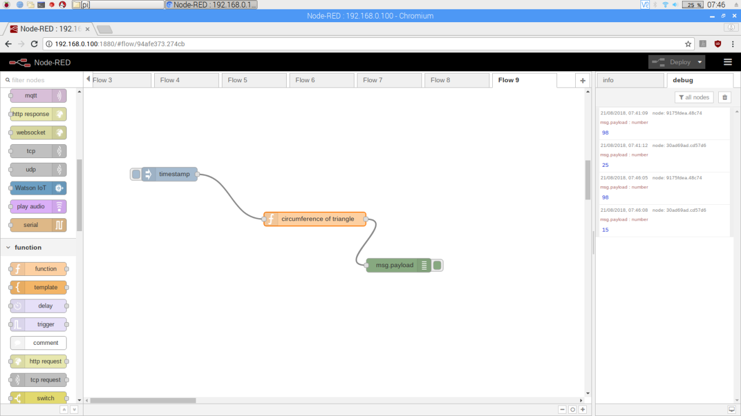

1. **Function to calculate the circumference of circle. Create the flow as given below.**



1. **Double click the function and add the code.**

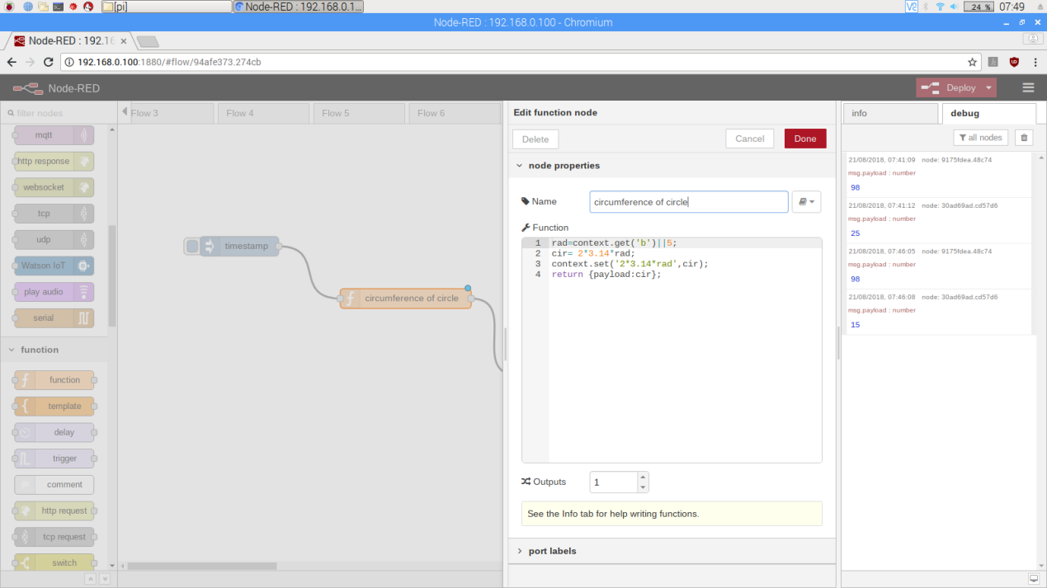

1. **Deploy and check the output.**

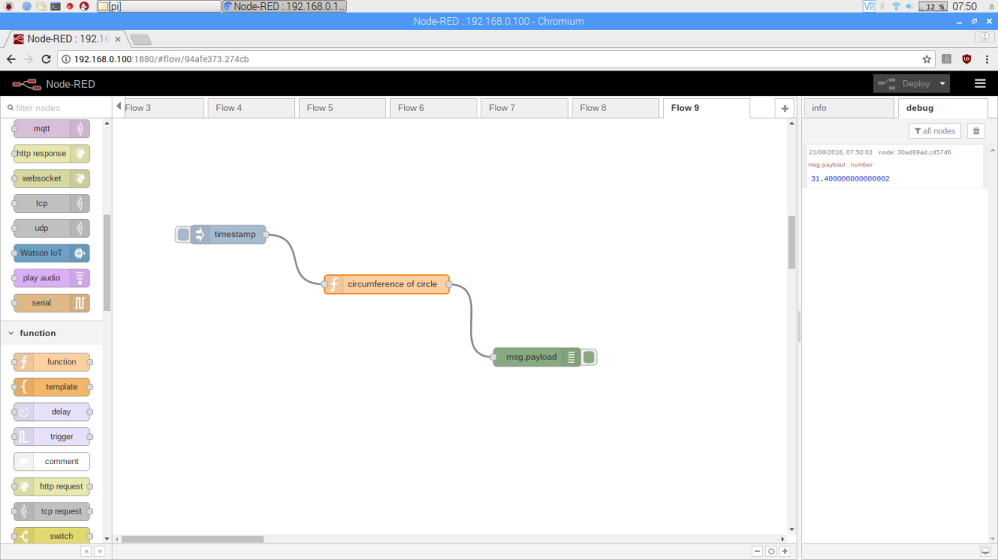

1. **Function to calculate the perimeter of square. Create the flow as given below.**

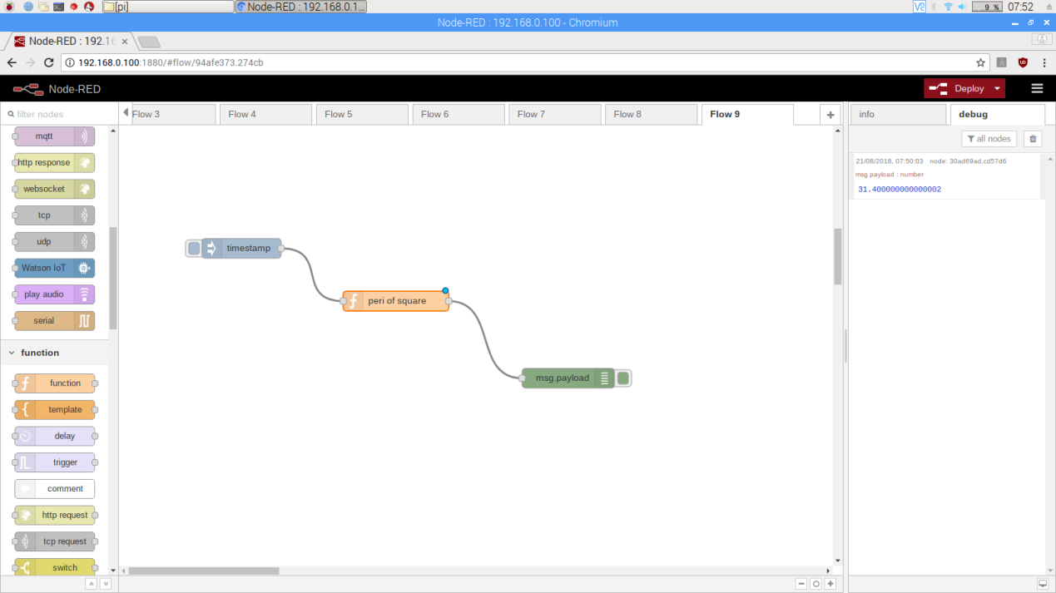

1. **double click the function and add the code.**

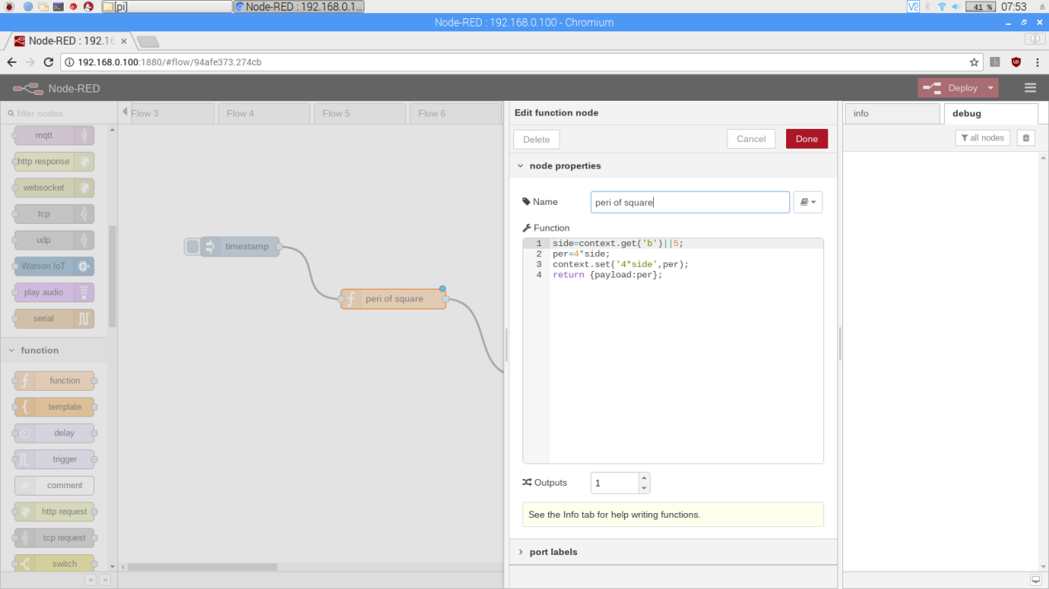

1. **Deploy and check the output.**

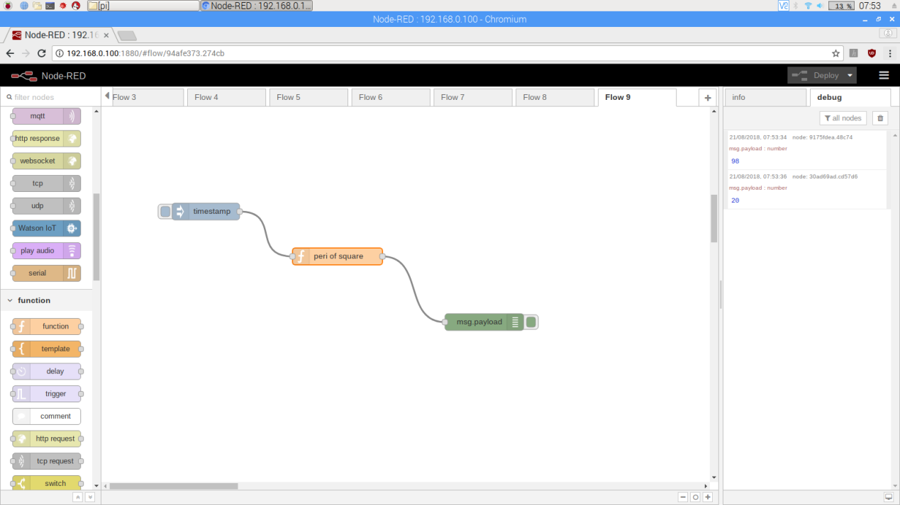

**Practical 6:**

Aim : How to install dashboard in NodeRED.

Step 1 : To Install NodeRED

Commands to Install NodeRED

Type the following commands in terminal

* sudo apt-get update
* sudo apt-get upgrade
* sudo reboot
* sudo apt-get install npm
* npm –h
* sudo npm l –g npm@2x

Step 2 : Go to node red and check “MANAGE PALLETE”

Step 3 : Go to install

Step 4 : Search dashboard and install

Step 5 : <http://192.168.0.110:1880/text> or page

Step 6 : <http://192.168.0.110:1880/ui>

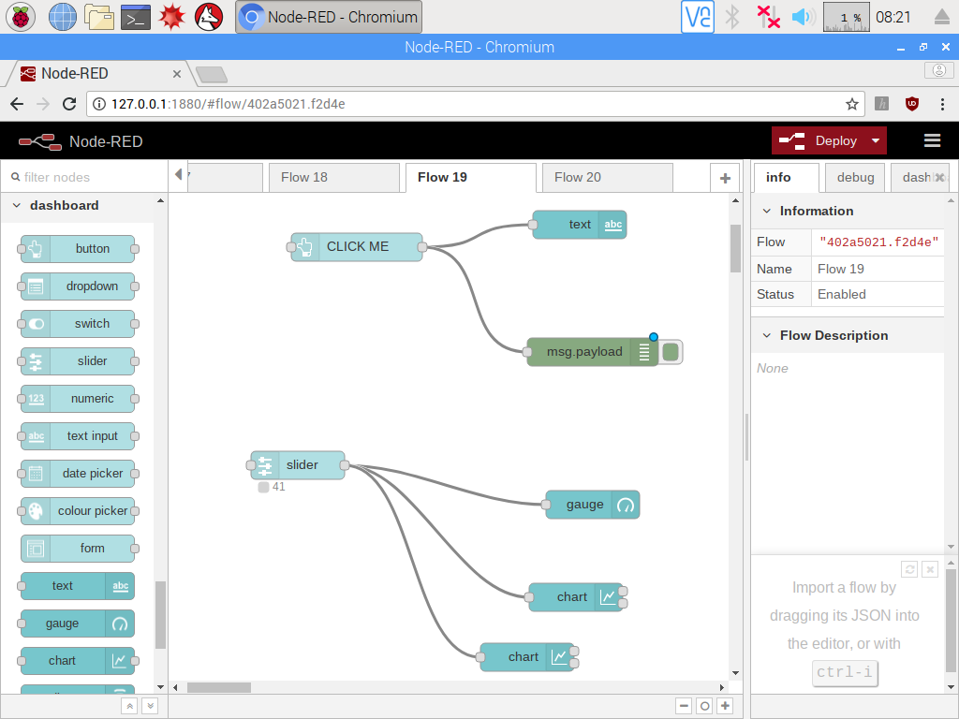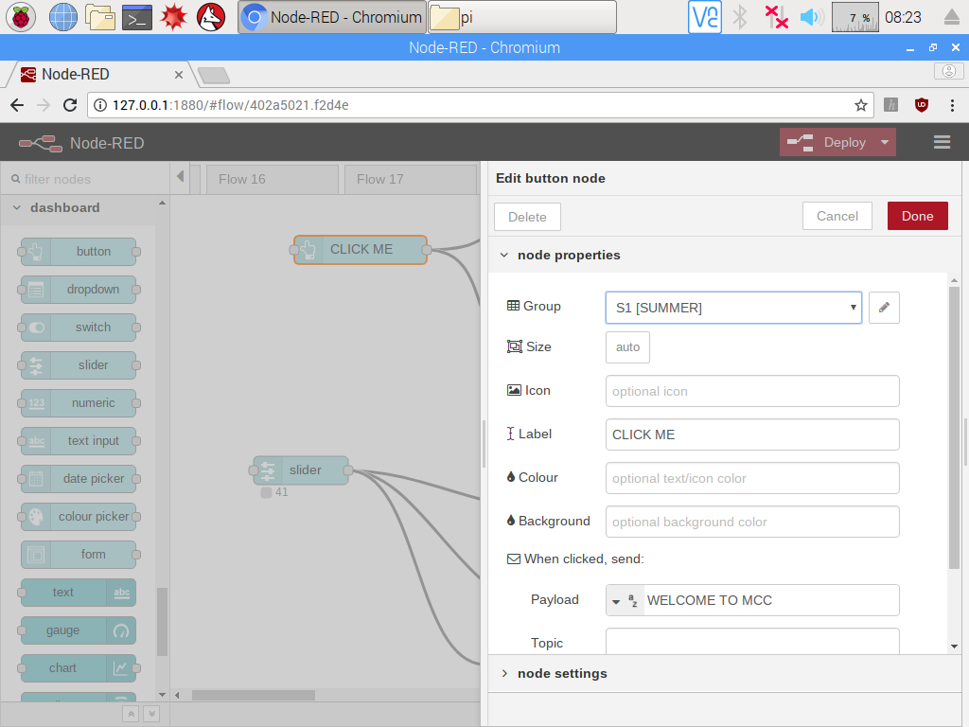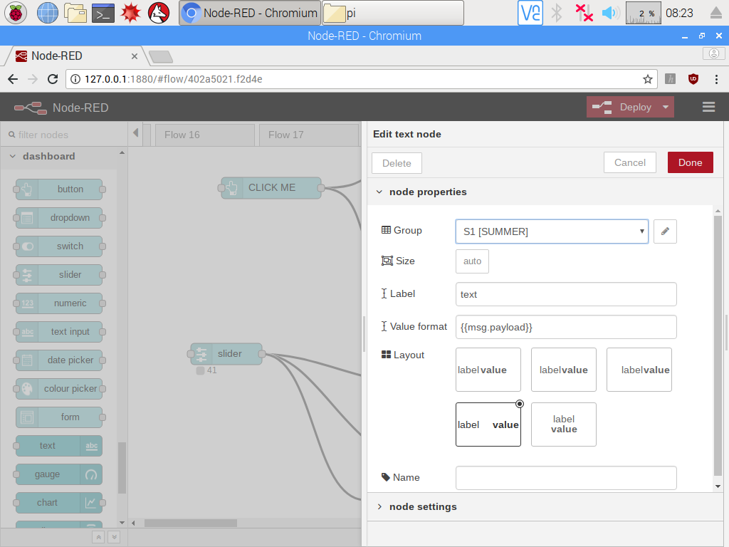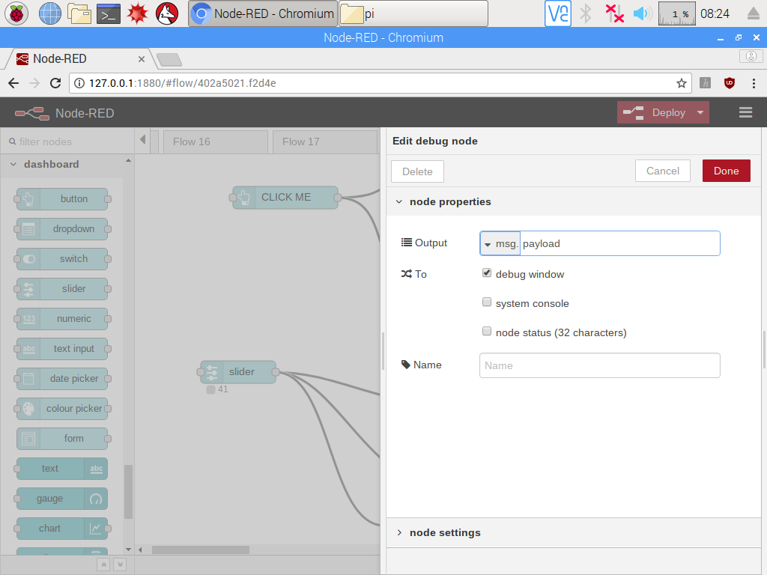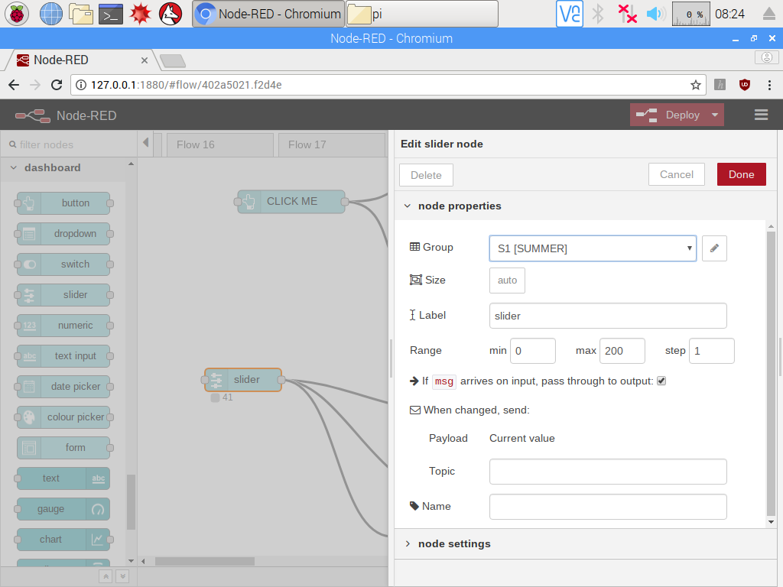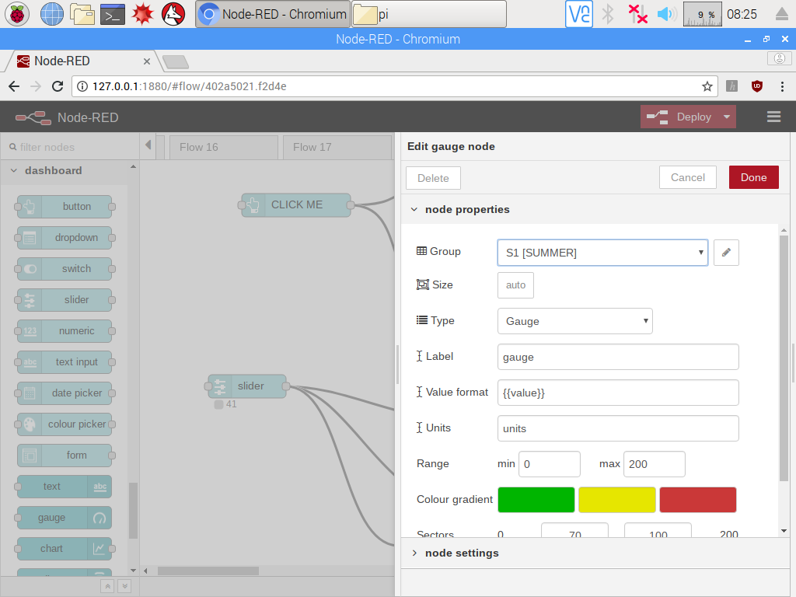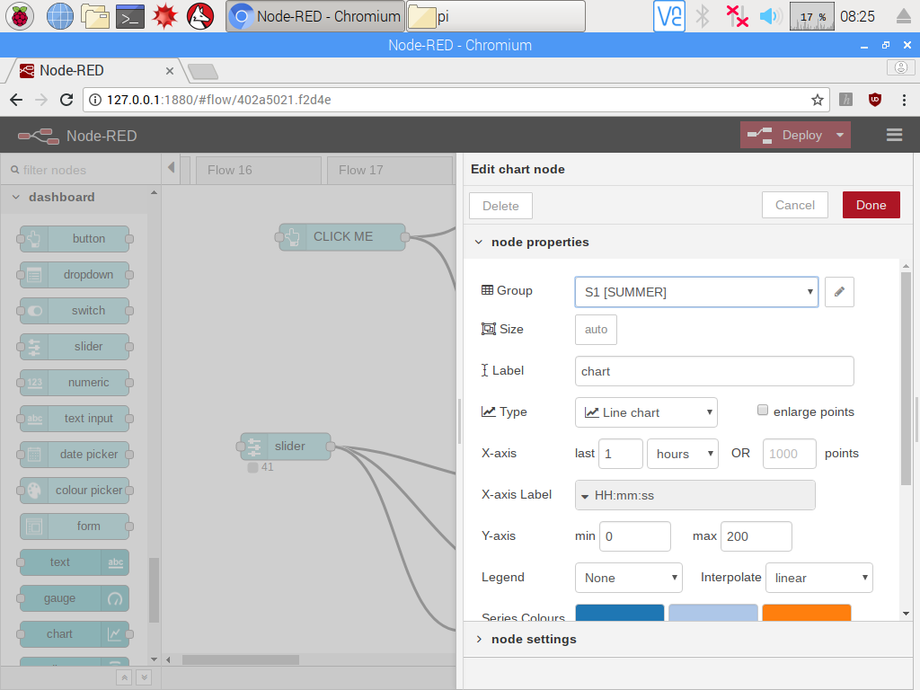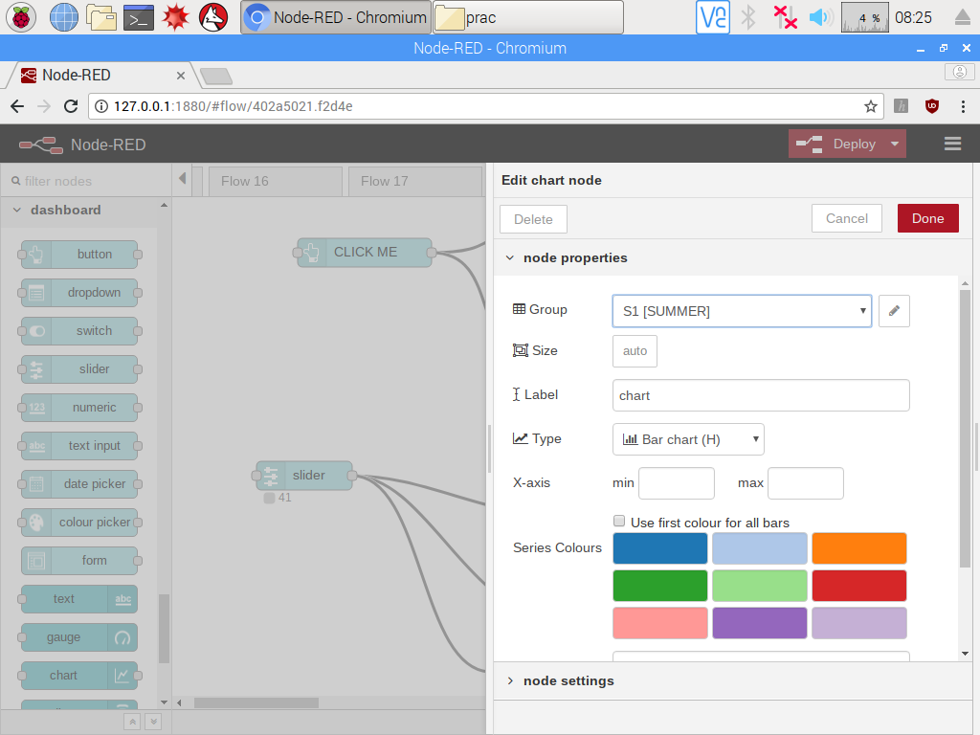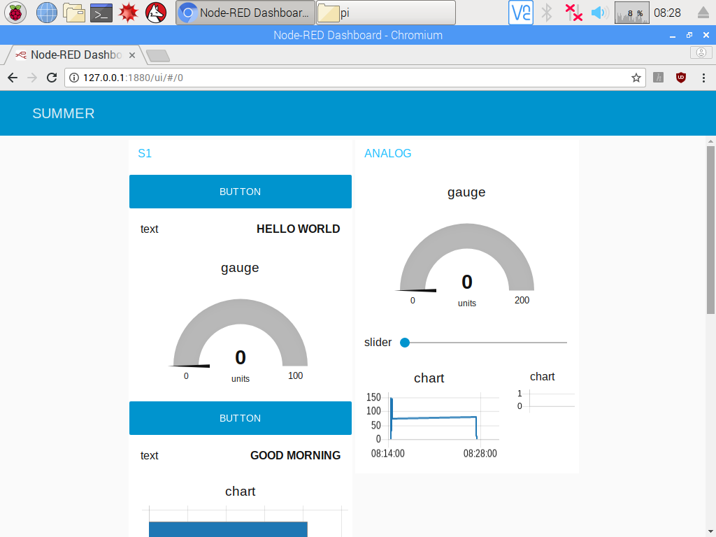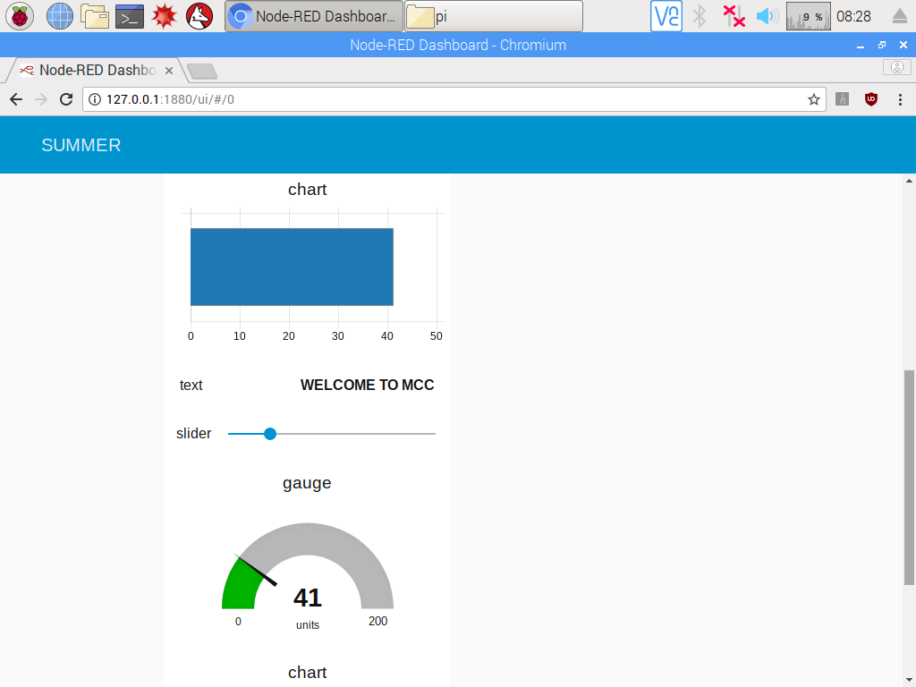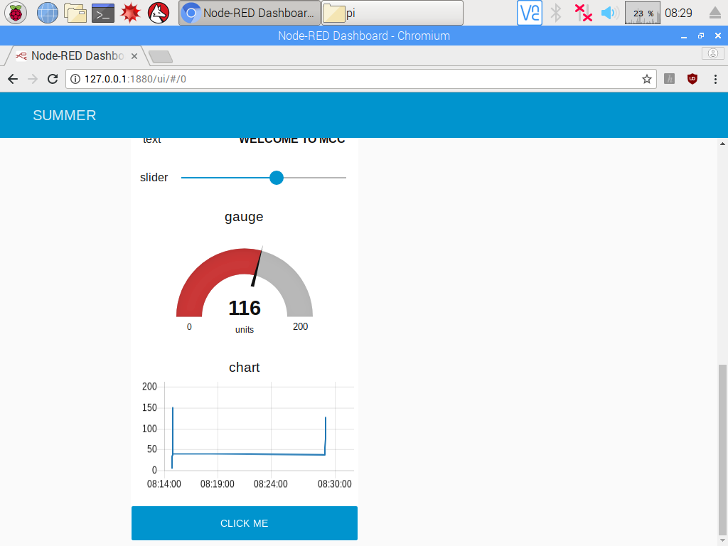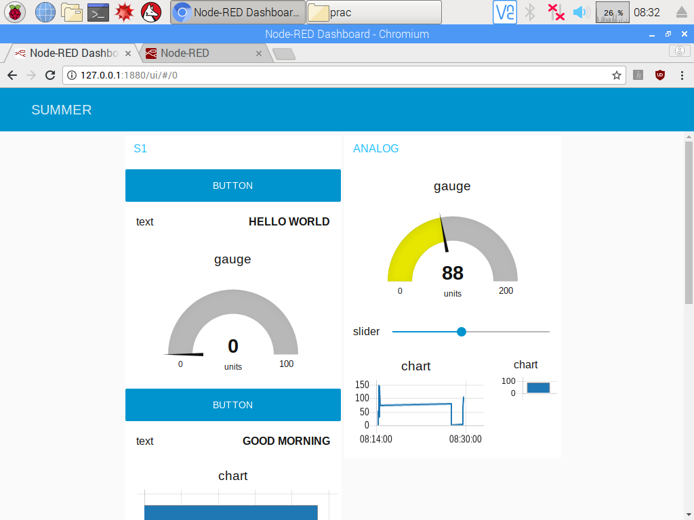

**Practical 8:**

**MQTT**

Aim : Set up the mosquitto MQTT server and client and write a python script to communicate data between Pi’s.

Step 1 :

Update the system

Sudo apt-get update

Step 2 :

Update the system repositories

1. Sudo wget <http://repo.mosquitto.org/debian/mosquitto-repo.gpg.key>
2. Sudo apt-key add mosquitto-repo.gpg.key
3. cd/etc/apt/sources.list.d/
4. sudo wget <http://repo.mosquitto.org/degian/mosquitto-wheezy.list>
5. sudo apt-get update
6. sudo apt-get install mosquitto

step 3:

install three parts of mosquitto proper

* sudo apt-get install mosquitto mosquitto-client python-mosquitto

step 4:

stop the server

* sudo /etc/init.d/mosquitto stop

step 5 :

Configuring and starting with the mosquitto

* sudo nano/etc/mosquitto/mosquitto conf
* log-dest topic
* log-type error
* log-type warning
* log-type notice
* log-type information
* connection_message true
* log-timestamp true
* include_dir/etc/mosquitto/conf.d

step 6 : Now start server

* sudo etc/init.d/mosquitto start

step 7 : Open two terminals using putty

1. At terminal 1 type the type following

* mosquitto_sub –d –t hello/world

1. At terminal 2 type following

* Mosquitto_pub –d –t hello/world –m “good morning”

